Bramingham Primary School - Geography Knowledge Organiser
Topic: Direction, Continents and Oceans | Year 2 | Strand: Locational Knowledge/Human and Physical geography
What should I already know? |  | Where do I live?
The country I live in is called England. •  I live in Luton, which is a town in England. •  England is a country in the United Kingdom (England, Scotland, Wales and Northern Ireland). • |  | Luton is a town in the country of England  England is in the United Kingdom  The United Kingdom is in the continent of Europe
Vocabulary
City | a large town. London is a city.
Compass point | any of the main points of a compass: north, south, east and west
Continent | a very large area of land that consists of many countries. Europe is a continent
Country | an area of land that is controlled by its own government.
England | a country in the United Kingdom. Luton is a town in England.
Island | a piece of land that is completely surrounded by water
Great Britain | An island that is made up of England, Scotland and Wales
Ocean | one of the five very large areas of salt water on the Earth's surface.
Sea | a large area of salty water that is part of an ocean
Surrounded | to be present all around
United Kingdom | The UK, is officially known as the United Kingdom of Great Britain and Northern Ireland. It includes England, Scotland, Wales and Northern Ireland
town | a place with many streets and buildings, where people live and work. Towns are larger than villages and smaller than cities
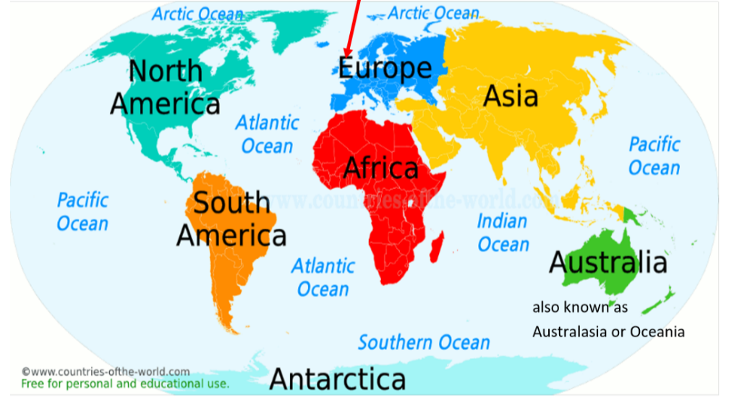
What will I learn about direction? |  | What will I learn about continents? |  | What will I learn about oceans?
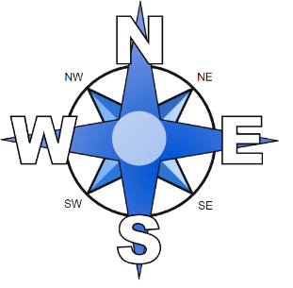  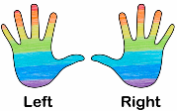 |  | There are seven continents: •  - Europe •  - Asia •  - Africa •  - North America •  - South America •  - Antarctica •  - Australia (also known as Australasia and Oceania) |  | There are five oceans: •  - Pacific Ocean •  - Atlantic Ocean •  - Indian Ocean •  - Southern Ocean •  - Arctic Ocean

Geographical Skills and Fieldwork
Find the five oceans and seven continents using map skills.
Can you also find them in an atlas and on a globe? •
Use Google Earth to find Great Cornard. Zoom out until you see the UK. Now zoom out until you see Europe. Now zoom out until you can see the world. Discuss what you notice. •
Use the compass points to describe the continents in relation to each other (e.g. Asia is to the east of Europe and to the north of Australia).

