2.7.20
To read and write compound words
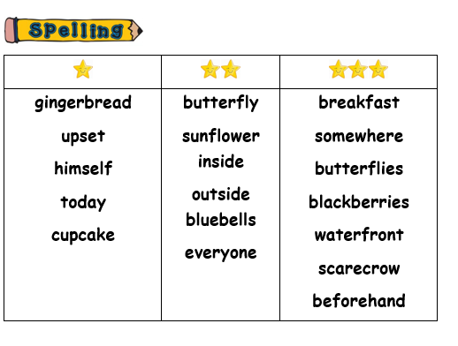
-Practise each word three times:
First try: | Second try: | Third try:

-

- Now try from memory!
-Use your words in nice sentences with capital letters and full stops/question marks.
-Can you use a conjunction (joining word) and, but, so, because when, if?

