BRAMINGHAM PRIMARY SCHOOL
SPECIAL EDUCATIONAL NEEDS AND DISABILITIES INFORMATION REPORT
October 2018

Meeting individual needs…to the best of our ability
At Bramingham Primary School we believe in achievement, ambition and progress for all children. We aim to meet the needs of individual children through highly effective teaching and learning. There is an emphasis on early identification of needs through supportive and preventative strategies which reduce barriers to learning.
We work in a flexible way to develop effective partnerships with children and their parents/carers, the SENCO, teaching staff and external professionals such as speech and language therapists, occupational therapists, physiotherapists, educational psychologist and child and adolescent health services (CAMHS) to ensure that the school can meet a broad range of special educational needs.
We are an inclusive school where every child matters; our aim is to address children’s needs and support their development in the most appropriate way. Additional and/or different provision is made for children with a wide range of needs, including:
- Cognition and Learning- Moderate Learning Difficulties and Specific Learning Difficulties
- Medical and Physical-We have resourced provision for children with physical and medical needs. We meet the needs of children who have Cerebral Palsy, Epilepsy and Diabetes.
- Communication and Interaction- Autistic Spectrum Disorder, Asperger’s Syndrome, Selective Mutism, Speech and Language Difficulties
- Social, Emotional and Mental Health- Attention Deficit Hyperactivity Disorder, Attachment Disorder

How do we identify and organise support for children with Special Educational Needs and Disabilities?
Identification takes place through:
- Daily observations, summative and formative assessments by school staff
- Dialogue with parents which is then followed by diagnostic testing and/or observations which gives us a more detailed insight into your child’s learning profile
- Liaising with pre school settings or other external agencies, where concerns about your child’s development may already be raised
- Once a need(s) is identified we meet with you to discuss the concerns and plan a way forward, monitoring and tracking progress closely. Interventions are planned and put into place - these may be carried out one to one or with small group support
- Your child will have an Individual Learning Plan (ILP) which is a document listing your child’s views, parents/carers views and termly targets that your child will be working on. This planned is reviewed termly and steps of progress can be measured.

Bramingham Primary Resourced Provision
- At Bramingham Primary we have resourced provision for up to 12 children with physical and medical needs. Our provision is an integral part of the school. Children who are supported by our provision are part of a class. They learn alongside their peers and access appropriate provision as and when it is required. Having resourced provision means our children can access:
- a physio room to carry out their physiotherapy led by trained staff
- regular access to a physiotherapist who bases her clinic once a week at school
- a clean room where medication is administered
- accessible toilets with a hoist and changing bed facilities
- a building on a single storey level, with wide corridors for wheel chair and walking frame access
- rise and fall tables, and specialised equipment such as sloping boards and ICT resources if required
- staff who have specialist training in administering medical procedures

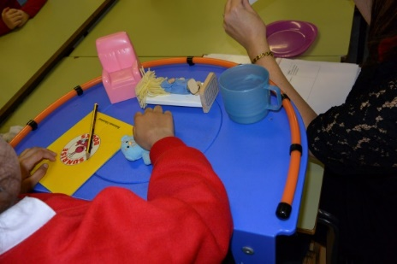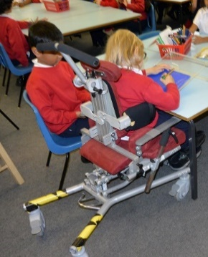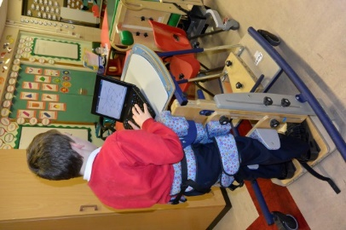

What is our approach to teaching children with SEND?
- We work in partnership with parents/carers and external agencies where appropriate and have high aspirations for our children, taking specific action to create effective learning environments, secure children’s motivation and engagement in learning. We have a ‘Can Do’ approach and look at how we can best adapt the environment and or resources for our children to access learning.
- All teachers are teachers of children with SEND. Quality first teaching takes place in all classrooms with the setting of high expectations and the provision of opportunities for all to achieve.
- A continuous cycle of planning, teaching and assessing is embedded, which takes account of the wide range of abilities, aptitudes and interests of our children. Children with SEND will receive support that is additional to or different from the provision made for other children. Teachers take into account children’s needs when planning and assessing.
- Staff plan opportunities to develop specific areas of need. They adapt the curriculum to meet the needs of the children. For example, children with physical difficulties will access physiotherapy as part of their curriculum, for children with communication difficulties there will planned opportunities to develop language and communication skills, children with specific literacy difficulties will access structured literacy programmes and children with social, emotional and mental and mental health needs may access social skills programmes.

How do we adapt the curriculum and learning environment?

- The curriculum is scaffolded and differentiated to meet the needs of all our children. The curriculum may be adapted through differentiation which may occur by:
-grouping (adult supporting small group work or 1:1 )
-adapting the content of the lesson
- different teaching styles
-adapting the lesson format
-provision of alternative recording methods such as using ICT, using bold lined books or a scribe
- adapting the resources
- provision of an alternative location for completion of work
- We take advice from external agencies eg enlarging of print, looking at positioning of children in the classroom, use of laptops, use of coloured overlays, use of sensory cushions and using aids such as a talking tin.
- For our children with literacy difficulties, our classrooms include use of labelled resources, word walls, prompt mats, keyword banks, reading rulers, coloured interactive boards and the use of Clicker 7 which is an ICT writing tool. We have reading books specifically designed to meet the needs of children with literacy difficulties.
- For our children with autism, we adapt their learning environment through having a work station if that is deemed to be appropriate, the use of visual schedules, prompt cards, providing routine and structure and using social stories. We provide a sensory circuit as part of the curriculum for our children who have sensory and physical needs.
- We endeavor to ensure that classrooms are speech and language friendly including the use of visual feedback, chunking of instructions, additional time is given to process instructions and there is pre teaching of vocabulary.
- We have small group rooms available for 1:1 or small group work.

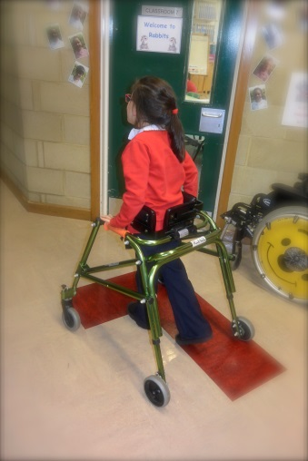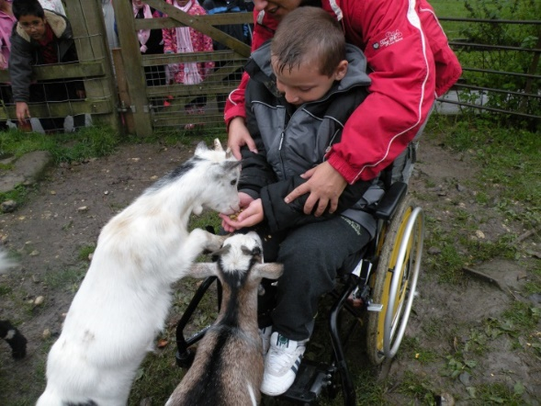

How will teaching be adapted to support your child with special educational needs or disabilities?
All our children work in the classroom alongside their peers for the majority of the time.
- For some children, they may need to access a workstation which may be in the classroom, just outside of the classroom or a different room for periods of time
- The curriculum is differentiated to meet all the children’s needs. Some children need a practical concrete curriculum and some aspects of their curriculum may focus on life skills or a greater focus on developing social and communication skills
- Some children need information to be chunked and require overlearning to enable them to generalise the skill. The pace of their curriculum may differ to that of their peers and it is likely the curriculum will be presented in a visual and kinaesthetic way
- Additional resources may be used to facilitate learning eg use of ICT
- If your child has individual teaching assistant support, verbal or written feedback is given from the teaching assistant and this enables the teacher to plan the next steps appropriately.
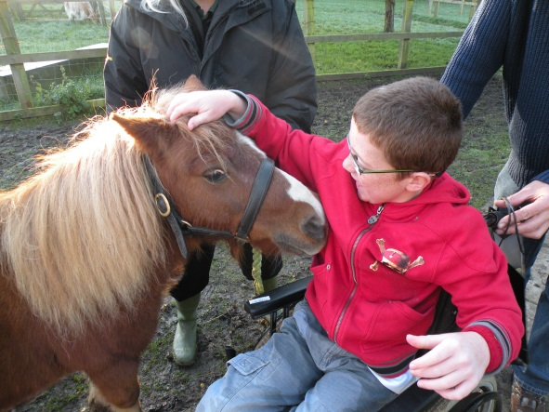

What different types of support can the child receive in school? (e.g. small group or individual)
The support your child receives depends on your child’s needs and the level of their need. In some cases, your child may be supported on an individual level and at other times, it may be small group level.
The different types of support that we may offer are listed below:
Intervention | Target Group
Early Reading Research Programme | Children who are struggling to grasp phonics
Toe By Toe | KS2 children who are struggling to blend in order to read
WASP | Year 2 upwards for children who are struggling to read and spell phonetic and regular words
Reading For Meaning | Children who are struggling to decode efficiently in order to read
Reading probe | Children who are struggling to develop a sight vocabulary for reading
Spelling and Reading probes | Children who are struggling to develop keyword reading and spellings
Wordshark | Children who are struggling to read and spell
Horse riding | Children who have physical / communication difficulties and are working on an individualised curriculum
Speech | Children who are under Speech and Language Therapy service and have a specific programme (co-ordinated by the speech therapist) to develop their speech
Language:  Foundation Steps, Derbyshire language Scheme, Communication Cookbook, Narrative Project,Language For Thinking, Colourful Semantics | Children who have comprehension or receptive language difficulties, children who have word finding difficulties
Social skills | Children who need specific teaching due to social and communication difficulties
Physiotherapy | Children who have physical difficulties. This may include using a standing frame and using a walking frame. This is under the direction and guidance of the physiotherapist.
Occupational Therapy | Children who have fine motor skills difficulties
Keyboard Skills | Children who require an alternative means to recording. We have enlarged keyboards and switches to access the laptops.
Maths Plus 1, Power of 2 | Children who are struggling to grasp basic skills in maths
Lunchtime club | Children who are unable to access the busy hall to eat lunch and playground. A smaller, quieter setting is provided.
Homework Club | Children who may need additional support to complete their homework.
Communication Group | Children who need support with their attention skills
Reciprocal Reading | Children who need support with reading comprehension
Sensory Circuit | Children who have sensory processing difficulties
Lego Therapy | Children who have communication difficulties
The progress from these different programmes is closely monitored and reviewed.

How will we support your child in unstructured times such as lunchtimes and playtimes and enable her/him to have access to after school clubs, school trips and journeys?
- Some of our children need additional support during the unstructured times. The support may be a teaching assistant or lunchtime assistant who has received training to meet your child needs
- For some children who find lunchtimes difficult, there is an alternative room to eat lunch which is less busy than the hall and then there is the opportunity to access an enclosed play area rather than the main playground
- We have social skills groups where children have the opportunity to problem solve and discuss acceptable ways to diffuse conflict or look at other ways they can manage their emotions. For some children, we write and share social stories which make appropriate actions and responses explicit when faced with difficult situations
- 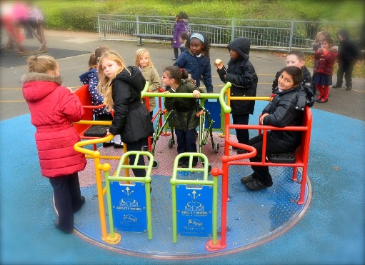
- Some children have the opportunity to choose a lunchtime buddy well before lunchtime in order to reduce any anxieties they may have about the social times. We have a buddy system across school, where every child has a buddy (an older and younger child are often buddied together)

- As an inclusive school, all our clubs are accessible. If your child wishes to attend an after school or breakfast club and they can only be supported by specific adults who have had specialised training, then we would organise an additional member of staff to support your child so they can access the club
- We carry out risk assessments for all school trips and we thoroughly plan how children will access the trip. With our ‘Can Do’ approach, we will make necessary adjustments and adaptations so every child has the opportunity to access school trips, which include residential trips. We liaise with the venue beforehand if additional resources such as a clean room is required and we plan for transport. We have a minibus with a tail lift that we use for children who are non ambulant. We send additional adults on the trip if we feel that at times some children may need two adults at one time eg for toileting
- To ensure trips are a successful experience for all, particularly residential trips, we meet with parents to go through the plans, as we aim to be as informed as possible about your child’s routines outside of school to ensure the trip goes ahead as smoothly as possible.
- Our sports day is adapted and tailored to suit individuals so that all children are able to access the events alongside their peers.

How will you be informed about your child’s progress within the setting and how will his/her progress be measured?
- Progress is continually monitored by your child’s class teacher. Staff will touch base with parents/carers on a regular basis if this is deemed appropriate
- Parents/carers are invited to two annual open evenings and will receive an annual written report
- If your child has an Individual Learning Plan (ILP), parents will be invited to contribute to and review the ILP. The ILP will specify short term targets and actions and these are reviewed termly
- Some of our children have home/ school communication books where daily information is shared between home and school
- For those children who have a Education Health Care Plan (EHCP), an annual review takes place where parents and all external agencies involved in your child’s development and learning are invited to attend to discuss your child’s needs and progress so far and plan for future targets and actions. Interim meetings are held if required.
- All parents are invited to spend a half day in class alongside their child each year. This gives parents/carers an opportunity to see the provision in practice at school.
- Progress is measured against the school assessment system. At the end of Key Stage 1 and 2 children are formally assessed using Standard Assessment Tests (SATs)
- We also measure progress through language, reading and spelling tests, which are administered twice a year
- If your child is in Year 1 and above, and is not able to access the national curriculum, a more sensitive assessment tool is used which shows the smaller but significant steps of progress. For some of our children we record progress in the ‘I Can Do’ books. These books contain evidence of a wider range of skills such as development of motor skills, social skills and working with independence.

What support do we offer to ensure the wellbeing of children with special educational needs and disabilities?
- For some children a keyworker is allocated- this may be a teaching assistant, family worker or a member of SLT. This member of staff will meet regularly with your child and or the parent/ carer to address concerns, plan, monitor and review actions
- We have social skills groups where children have the opportunity to problem solve and discuss acceptable ways to diffuse difficult situations or look at other ways they can manage their emotions
- We work with external agencies to provide children the support they need. The interventions can take place at school and can be led by other professionals such as the school nurse, the Young Carers support group, the Strengthening Families team or the Greenhouse Mentoring service.
- If we have concerns about your child’s attendance, our family workers, SENCo or Headteacher will work with the family to ensure your child accesses school. Our Education Welfare Officer regularly monitors the attendance of our children and any concerns will be shared. School staff may also go to the home and bring your child into school if they are reluctant to attend school.
- For children with medical needs, we have a clean room where regular medication and medical procedures are carried out eg gastrostomy. Our staff are trained by the nursing staff to administer medications and care plans are in place and are followed to ensure all procedures are carried out correctly.

How do we consult with children with SEND and involve them in decisions that affect them?
We believe it is important to hear the ‘child’s voice’. This is achieved by:
- Your child will be encouraged to contribute their views about their development and progress. Children are invited to attend and contribute to their open evenings with their parents to discuss their progress
- If your child has an Individual Learning Plan, as part of the review, he/she will have the opportunity to review their progress against the targets set. As part of this discussion your child will be encouraged to share what works well for them in school, how they want to be supported and they are encouraged to recognise their strengths and areas they wish to develop. If required, staff will scribe for your child
- For children with an Education, Health Care Plan, as part of the annual review process, your child will be invited to attend part of the meeting to share their views, if this is deemed to be appropriate. Where this may be difficult for some of the children, a questionnaire seeking your child’s views is carried out prior to the review and your child’s views are then shared at the meeting.
- Your child will be invited to attend transition meetings and they will have the opportunity to list their questions, views and concerns so they can ask the relevant members of staff
- Pupil questionnaires are used to seek children’s views about their learning and their experiences at Bramingham Primary
- Some children complete an ‘All About Me’ questionnaire, which gives your child the opportunity to share with staff and peers what they feel works/ helps them with their learning
- All children have the opportunity to stand for School Council. Nominees are voted for by the class. School Councillors are expected to listen to the views of all the children in their class and share them with the School Council.

How are our school’s resources allocated to support children with SEND?
- Children who have resourced provision have their physical and medical needs met by the funding provided by the Local Authority
- Children who have a resourced provision place have allocated funding and top up funding which provides teaching assistant support to meet their learning and medical/physical needs. This may require two adults at one time eg for administering medication, toileting or school trips. Any additional equipment your child may need to access their learning eg ICT resources, will also come from this budget. If the cost for a piece of equipment exceeds £1000, we apply to the Local Authority for funding
- Children who have anEducation Health Care Plan, but do not have a place in the resourced provision have some allocated funding from the Local Authority and additional funding is provided from the school budget. The funding is used to provide individual or small group support to meet your child’s needs in order to access the curriculum, lunch and playtime support and support for school trips and resources if needed
- For those children who do not have anEducation Health Care Plan, support is provided from the school budget to access the curriculum, either one to one or in a small group, or to carry out interventions to target the area of concern.

What support will parents/ carers receive if your child has been identified as having special educational needs?
If your child has been identified as having additional needs, we liaise closely with parents/ carers in the following way:
- Regular meetings between school staff and parents will be held to share findings and discuss actions and progress. Parents are encouraged to meet with school staff to share concerns they may have.
- Our family worker holds regular coffee mornings where parents of children with additional needs have the opportunity to meet together. Sometimes outside agencies are invited to lead talks or share information about services parents can access. Our SEND governor has attended a coffee morning to hear the views of parents/ carers.
- We sign post parents to the Parent Partnership services if they feel they need additional support or guidance that we are not able to provide
- We advertise external events for parents and where we feel a particular support group may be of benefit to a parent, we will send the parent particular details and information and encourage them to attend.
- If appropriate we can complete an Early Help Assessment to support families who may be experiencing difficulties at home which may be related to their child’s special educational need. Depending on the family’s need, this can trigger additional support for families

What services external to our school can provide support to children with SEND?
The following external agencies may be involved with your child’s learning and development. Initial discussions take place with parents before seeking external advice. Following discussions with parents, if appropriate, the school can refer your child to the following specialists:
External Agency | Referral Process | Service Provided
Educational Psychologist | School referral | Educational psychologist will observe your child in school/ carry out relevant assessments, speak to relevant school staff, meet with parents. A report is written to share observations/ findings about your child’s development, along with the actions for parents and school to action.
Behaviour and Tuition | School referral | A member of the Behaviour and Tuition team will observe your child in school and will talk to relevant school staff and may meet with parents. A report is written to share observations/ findings, along with the actions for parents and school to action.
Autism Team | School to complete  referral form. A diagnosis of ASD is needed to meet criteria for referral. | A member of the Autism Team will observe your child in school, speak to relevant school staff and meet with parents. A report is written to share observations/ findings, along with the actions for parents and school to action.
Speech, Language and Communication Needs Advisor (SLCN) | School to complete  referral. | The SLCN advisor will observe your child in school, speak to relevant school staff and carry out assessments. A report is shared with the family and school and the next steps are documented.
Speech and  Language Therapy | School to complete  referral form. | The family are invited to attend an initial appointment at the clinic. A report is written and shared with home and school. School implement any actions, incorporating targets in IEPs. If your child has a Statement of Special Educational Needs and are under the services of speech and language, the therapist will visit and assess the child in school.  For children under the age of 5, there are speech and language drop in clinics which parents can attend with their child
Edwin Lobo Centre | School or doctor to complete referral form | Your child is invited to attend an appointment with the community paediatrician. Prior to the appointment school is often presented with questionnaires about your child’s development as part of information gathering. At times, school may write a written report as additional information and sometimes a member of staff will attend the appointment with the parent/ carer and your child.
CAMH  (Child And Mental Health) | School or doctor to complete referral form | Your child is invited to attend an appointment with the parent/ carer. With parental consent a report may be shared with school.
School nurse | School to complete referral form. | School nurse to meet with school and parents to health/ medical discuss concerns and plan next steps
Occupational Therapy | School or doctor to complete a referral. | Your child is invited to attend an appointment with the parent/ carer at the clinic. A report is shared with school and school implement the actions. Some children who are under the Occupational therapy services may be reviewed at school.
Physiotherapy | Referral through doctor | Child to attend clinic/ hospital. Children who have regular physiotherapy are seen at school as the physiotherapist runs her clinic for one morning per week at school.
Continence service | School or doctor to complete referral | Child attends appointment with parent/ carer. If a toileting programme is in place, this is followed at school.
Lady Zia Outreach Team | School to complete ICT/ Curriculum/PE referral | Outreach team come into school. They observe your child and carry out relevant assessments. A report is shared with school and home and actions are implemented with school purchasing the necessary hardware/ software.
Epilepsy team/ community nurses | Referral through doctor | Due to our resourced provision, we liaise very closely with the epilepsy service and community nurses.
Greenhouse Mentoring Service | School referral | A mentor or group support will be offered if the referral is accepted.

All of the above referrals are completed with parental consent.
How are staff in our school supported to work with children with special educational needs and what training do they have?
- The needs of the school influences what training is planned. Where whole school awareness is needed because of your child’s needs, then training is revolved around that, eg epilepsy awareness
- Training has been led by the Educational Psychologist or the Autism team. Outreach advice may be sought for individuals eg from Lady Zia Outreach. The SENCo or Provision manager ensure that all staff involved with your child’s learning are fully aware of what approach or resources are needed
- Our teaching assistants attend fortnightly training. The training is based on the needs of the children they are working with. External trainers, such as the nurses or autism team will deliver training as well as staff in the school. Training is also provided by school staff such as the SENCo, maths co-ordinator, English co-ordinator, and the phonics co ordinator.
- The SENCo is a trainer for online autism training. Some of our teaching assistants and teachers have completed this training
- If your child has medical/ health needs, we aim for at least 3 members of staff to be trained in administering procedures under the guidance and supervision of the nurses/ physiotherapist. The training is carried out under the close supervision of medical staff. Care plans are in place and adhered to.
- Additional planning time is allocated for teaching assistants and class teachers for children who are working at P Levels (not yet accessing the National Curriculum).
- Some of our staff also access online training eg safe guarding training, fire safety awareness and online INSET eg autism training
- Staff also attend training courses provided by external agencies eg autism, sensory processing, attachment, manual handling, diabetes training, and attachment. There have been opportunities for staff to visit our local specialist provisions to look at outstanding practice.

How will we support your child in moving on to another school or college or to the next key stage in their education or life?
- As your child moves on to the next stage of their education, it is vital that a smooth detailed transition takes place from one setting to the next. Managing the change to, from and within school is planned very carefully. Parents and children are involved in this process.
- For those moving onto high school, we begin to plan for transition when your child is in Year 5. This involves the SENCo requesting external agencies such as the Educational Psychologist to provide updated reports in preparation for transition. We encourage parents/ carers to begin to look at prospective schools so there is enough time to plan the transition carefully.
- For children who move onto another setting, meetings are held with the prospective school and parents to ensure all information, training needs, and strategies are shared. We involve your child by asking them their views and they meet prospective school staff. We accompany children to their new setting as many times as it is deemed appropriate. Any professionals that are involved in your child’s learning are invited to be part of the transition process. We hold a review meeting to ensure the transition plan has been followed and training needs are in place and to discuss if anything additional is needed before your child leaves. At the time your child leaves us, we ensure all written information is passed on to the new setting
- For children who are joining us, we meet with the current setting, we observe your child in their setting and then we invite your child to visit Bramingham with their parents or current school staff. We prepare transition books for your child to take away with them so they can look at key personnel and places for when they join us. Once your child has joined us, we will hold a review meeting to discuss how your child has settled
- When moving to the next year group, we provide social stories to prepare your child for the upcoming change. Children spend at least a day with their new class teacher and where possible, we aim to keep the same support staff if you child has 1:1 support. This allows for continuity and consistency for you child. We provide transition books and we encourage children to voice any questions, views or concerns they may have so they can ask the relevant member of staff. Parents have the opportunity to meet the new class teacher so they are able to share information and ask any questions they may have . Information is passed on to the new teacher. The SENCo will liaise with teachers to ensure a smooth transition. The ‘All About Me’ booklets are kept up to date and are passed to the next class teacher and support staff.

How accessible is our school environment?
As we have resourced provision for children with physical and medical needs we offer:
- A single storey building
- Wider doors for wheelchair access
- Ramps for our huts
- Adapted sports equipment
- Adapted ICT equipment
- Adapted classroom resources eg. rise and fall tables
- Adapted toileting facilities
- Adapted play equipment eg wheelchair accessible roundabout
- A clean room for specialised medical procedures to be administered

Key Personnel
If you wish to discuss your child’s needs or you have any concerns regarding your child, you may contact the school to speak to:
- the SENCo- Mrs Bains, or Assistant SENCo - Mrs Sutton
- the Provision Manager - Mrs Shepherd
- the Head Teacher, Mrs Flowers
- the SEND Governor

- We welcome parent/ carers views and we will always invite parents into school to discuss any concerns they may have about their child’s development, learning, well being or provision.

Admissions
- If your child has anEducation Health Care Plan and you would like to transfer your child to Bramingham Primary, you will need to contact the Special Educational Needs Assessment Team (SENAT) at Futures House. SENAT will then forward the application along with information about your child’s needs so our school can make an informed decision to see whether we will be able to meet your child’s needs. The decision is then made by the Local Authority’s Statutory Provision Assessment Panel (SPAG) as to whether our school is the most appropriate placement to meet your child’s needs
- For those of you who wish to request a placement at Bramingham for your child to access resourced provision, as your child has a physical or medical need, your child must have an Education Health Care Plan in order to apply for a place. When making an application to SENAT (as above) you need to indicate at this stage you are applying for resourced provision
- In all other cases, you would need to make an application through the local authority admissions team. You may access further information about Luton’s Local Offer at directory.luton.gov.uk/kb5/luton/directory/lo_info.page

