Thursday 25th June
South Africa
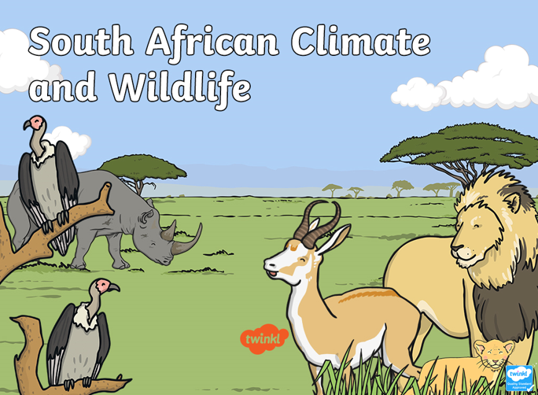
We are learning about the weather, climate and animals found in a hot place (South Africa). Read the information on the PowerPoint and have a go at the questions below.

- Where is South Africa located?
…………………………………………………………………………………………………………………………………..
- What does ‘climate’ mean?
…………………………………………………………………………………………………………………………………..
- Describe the climate in South Africa.
……………………………………………………………………………………………………………………………………..
- Which are the fastest mammals on Earth?
………………………………………………………………………………………………………………………………………
- What do pangolins like to eat?
……………………………………………………………………………………………………………………………………..
- Which type of rhino would you find in South Africa?
……………………………………………………………………………………………………………………………………..
- Zebras often graze with which other animal?
…………………………………………………………………………………………………………..
- Share an interesting fact about humpback whales.
…………………………………………………………………………………………………………………………………….
- What is South Africa’s national bird?
………………………………………………………………………………………..

