Menu of Home Learning Activities
Thursday 18th June

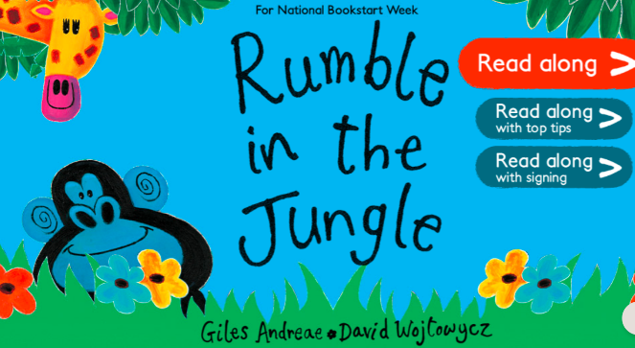
Reading: Learn to read fluently by reading along to Rumble in the Jungle.
Click on the link below….no logging in or registering needed – lots of stories to practise reading along to.
https://www.booktrust.org.uk/books-and-reading/have-some-fun/storybooks-and-games/rumble-in-the-jungle/
Whatever you choose, practise reading until you can read more of it fluently than you could to start with. You can listen to your book as many times as you like. You can send us a video of you reading if you would like to.
Maths – Mrs Chidwick will teach you how to make doubles.
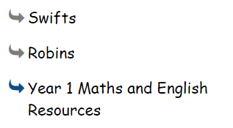
Go to ‘Year 1 Maths and English Resources’. See left.

Don’t forget to Doodle!

Writing – Miss Fitzgerald will teach you how to innovate on a story and use speech. Go to the ‘Year 1 Maths and English Resources’ page.

Phonics – To learn your new spelling words
We have been learning different graphemes for the long ‘ee’ phoneme (sound). Choose a set of words to learn and practise. Can you write a sentence using a conjunction such as and, but, because, so?

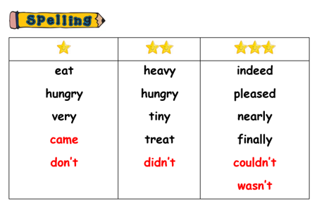

Optional activity
Geography:

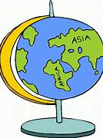
To begin to learn about climate zones.

Recap: Can you name the 7 continents and the 5 oceans?
What is meant by ‘climate’? It means the type of weather that a place normally has. Climates are worked out over about thirty years!
Climate types:
Warm - These places are nearly always warm/hot. You might see deserts. E.g., Africa.
Tropical - These places are warm/hot and they get a lot of rain. They are humid. You might see rain forests. E.g. South America.
Temperate - These places are not too hot and not too cold. They get some sun and some rain. England is temperate. E.g. The UK.
Cold - These places are always cold. You might see snow and ice. E.g. Antarctica.
-Look at the climate zone map (found on the web page)
-Mark on some places, including: England, India, Australia, Canada, African countries.
-Colour it in using the key.
-What are the climates of these places like?
EXT: Where are the hottest countries?

