Menu of Home Learning Activities
Monday 29th June

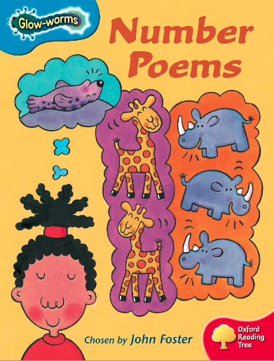
Reading: Learn to read fluently by reading along to Number Poems.
Click on the link below
https://www.oxfordowl.co.uk/api/digital_books/1352.html
Which is your favourite poem? Can you spot the digraphs we have learnt?

Writing – Miss Fitzgerald will teach you how to write the beginning of the story of The Gingerbread Man.

Maths – Come and learn about partitioning
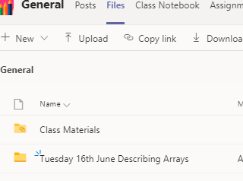
The video and worksheets are also in a folder in Teams Files: Monday 22nd June in case you have any problem here.
Watch the video we have recorded for you.

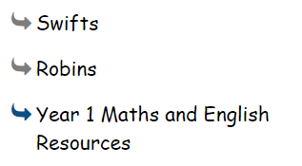
Go to the newly created Bramingham web page called ‘Year 1 Maths and English Resources’. See left.

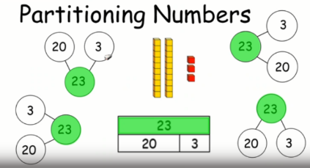
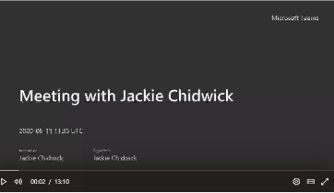
.

Then click on the picture (see left)
It may also appear as this picture:

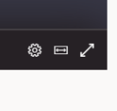
This will take you directly to the video stream. When you get there, click on the double arrow to enlarge the screen.

Don’t forget to Doodle!

Phonics - To learn ph, wh and kn
Read the words on the PowerPoint and complete the activity. Make 3 lists for wh, ph and kn. Can you write 3 words for each column?

Optional activities

Science on Purple Mash
There is a 2do set for you by special request!
You can watch video about sun safety at https://www.youtube.com/watch?v=T7ghJsZug60 about George the sunsafe superstar and complete the 2do.
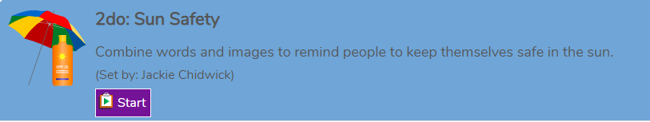

Computing:Coding

Access Discovery Education Coding at:
https://www.discoveryeducation.co.uk/what-we-offer/discovery-education-coding
Log in: student35491
Password: bramcode
You will begin to work on unit 1b (Simple Inputs). Do Lesson 4 - Emergency!

PE
Have fun doing 'The Name Workout'. Could you try your sibling's name? How about your surname?
