Menu of Home Learning Activities
Tuesday 23rd June

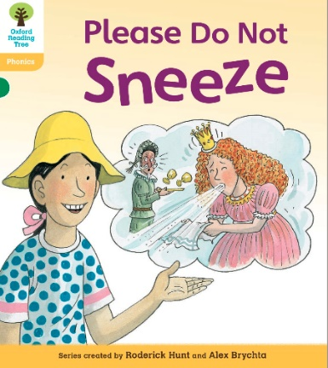
Reading: Learn to read fluently by reading along to Please Do Not Sneeze.
Click on the link below to practise reading along to.
https://www.oxfordowl.co.uk/api/digital_books/1352.html
https://www.oxfordowl.co.uk/for-home/library-page/?query=Please+Do+Not+Sneeze
You will use this in phonics today.

Writing – Miss Fitzgerald will teach you how to plan a new downfall for the gingerbread man.
In the model text, the gingerbread man meets his downfall whilst crossing the river. How else could it happen?
Have lots of fun thinking of all the sticky ends the gingerbread man might come to in your story!

Maths – Come and learn more about equal groups by sharing and see how this looks on bar models and part-whole models
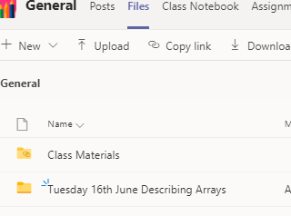
The video and worksheets are also in a folder in Teams Files: Monday 22nd June in case you have any problem here.
Watch the video we have recorded for you.

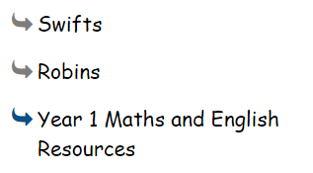
Go to the newly created Bramingham web page called ‘Year 1 Maths and English Resources’. See left.

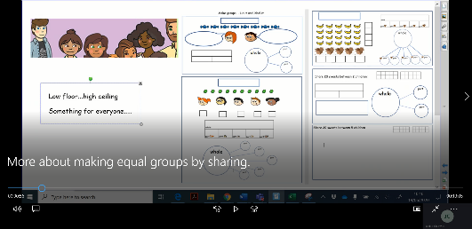
.

Then click on the picture (see left)
It may also appear as this picture:

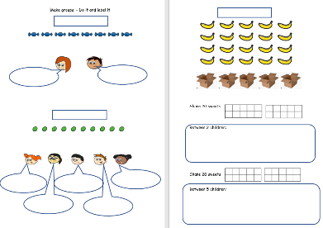

This will take you directly to the video stream. When you get there, click on the double arrow to enlarge the screen.

Don’t forget to Doodle!

Phonics -
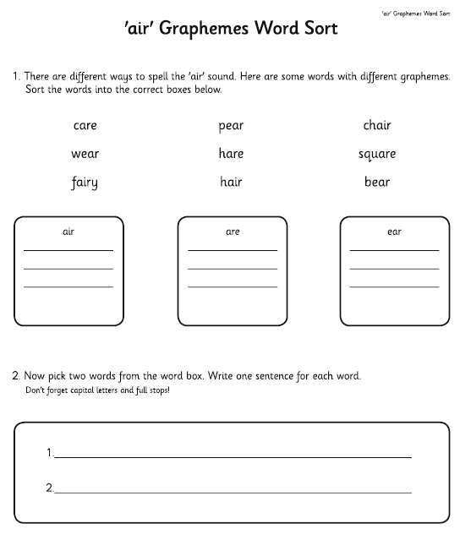
To learn ‘are’ care ‘care and share’ (another grapheme for air ‘that’s not fair’).
Can you sort the graphemes (letters) for ‘air’?

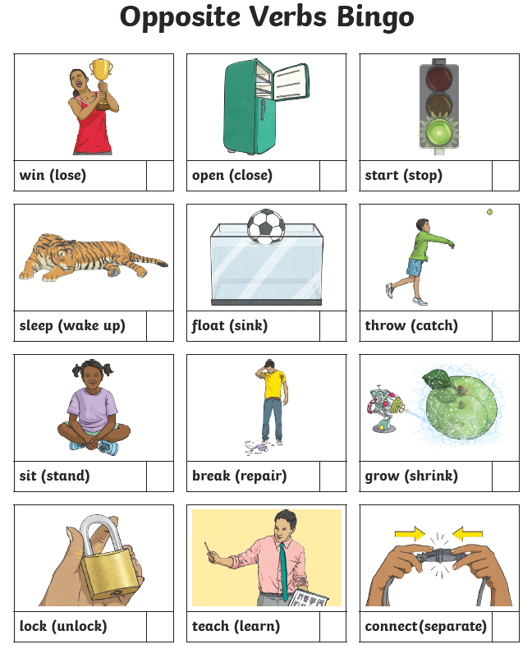
Optional activity: Match opposite verbs and adjectives

You might like to play the opposite verbs bingo or match the opposite adjectives on the sheet.

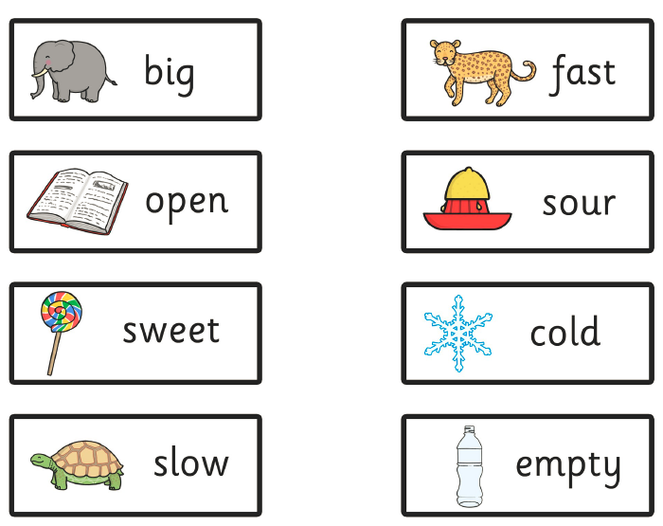

PE
Have fun doing 'The Name Workout'. Could you try your sibling's name? How about your surname?
