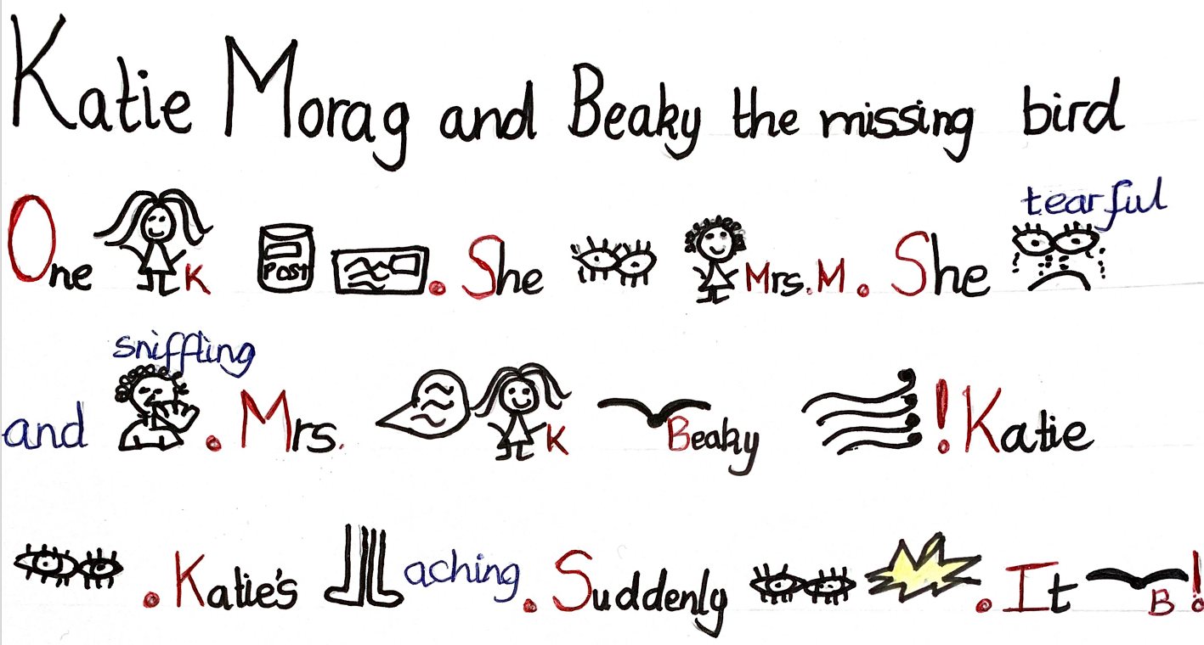

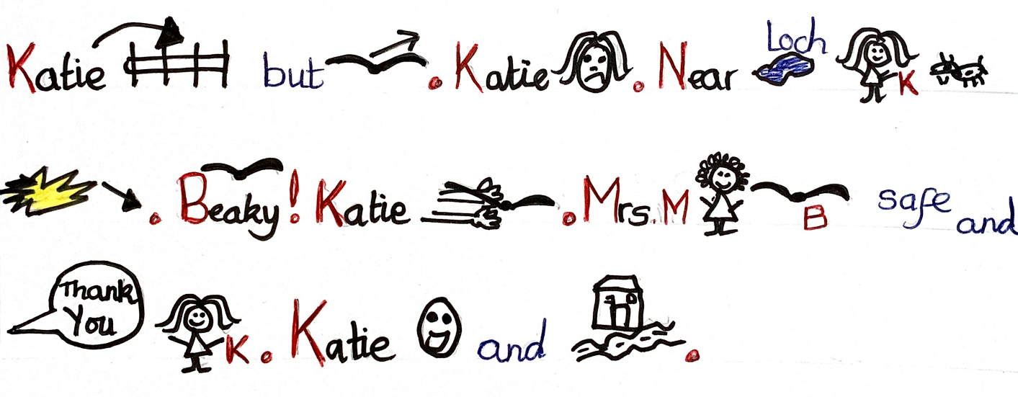
Katie Morag and Beaky the missing bird
One day, Katie Morag was posting a letter. She saw Mrs McColl. She was tearful and sniffling. Mrs McColl told Katie that Beaky the yellow bird had been blown away! Katie said that she would find him.
Katie’s long legs were aching. Suddenly, she saw a flash of yellow. It was Beaky! Katie leapt over the fence, but the yellow bird flew away. Katie was upset.
Near the loch, Katie saw a yellow flash swooped down to the ground. Beaky! Katie picked him up carefully.
Mrs McColl saw that Beaky was safe and she said thank you to Katie. Katie smiled and went home.

