Nearpod instructions
This is what the Nearpod application looks like for those downloading the app
Working on the internet
Go to | www.nearpod.com
 | 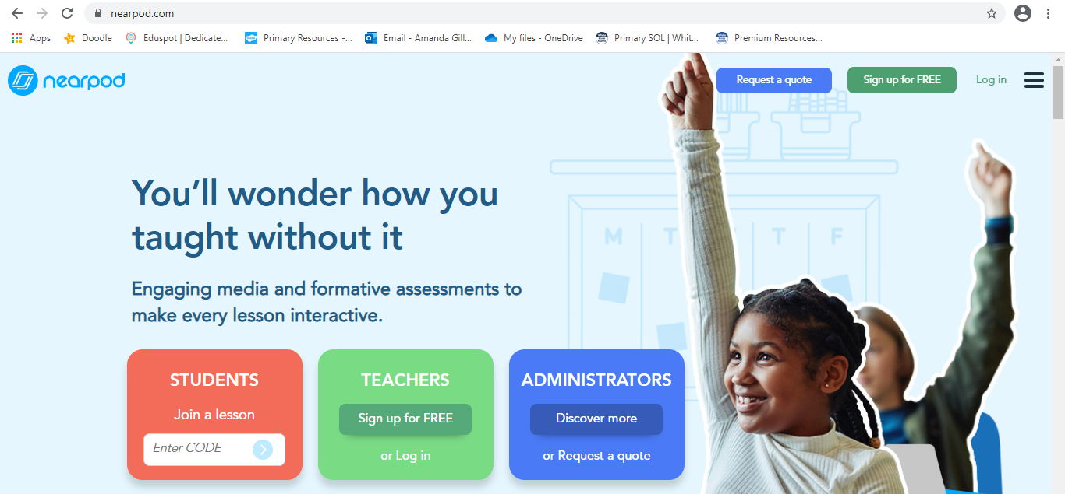
Go to | Students: Join a lesson  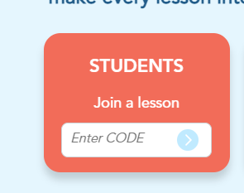
Type in the code which will be found in the Year 5 chat. Use capitals when copying or copy and paste the code directly from the chat You will be tagged in the message containing the code so it can be easily found through the ‘Activity’ tab.

