Menu of Home Learning Activities
Tuesday 7th July

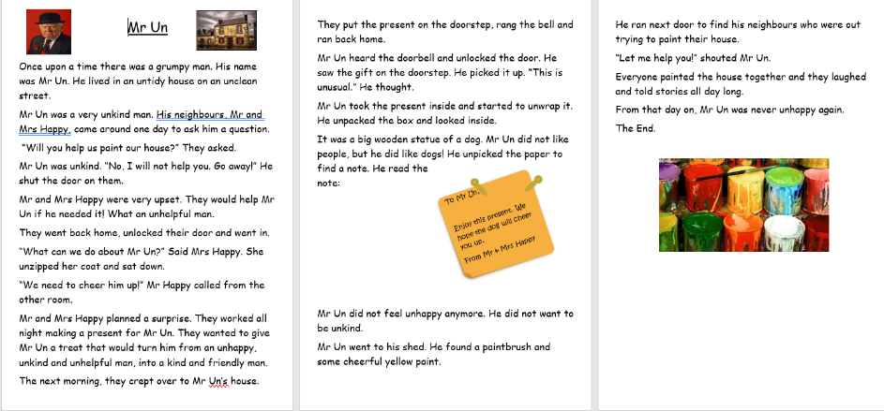
Reading: Read Mr UN
You may need a grown up to read it to you first and then practise reading as much of it by yourself as you can. Try keeping the speed and expression going.

Remember to pause at the full stops!

Writing – Miss Fitzgerald will teach you how to answer questions about her text to show that you can read with understanding.

Maths – Come and learn more about finding a half
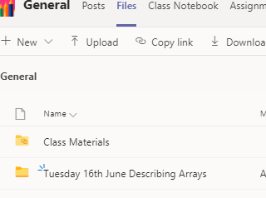
The video and worksheets are also in a folder in Teams Files: Tuesday 7th July in case you have any problem here.
Watch the video we have recorded for you.

Go to the newly created Bramingham web page called ‘Year 1 Maths and English Lessons and Resources’.
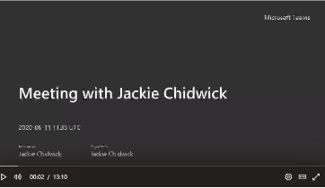
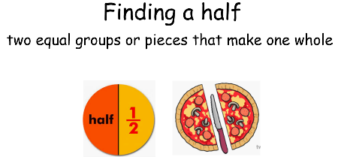
.

Then click on the picture (see left)
It may also appear as this picture:

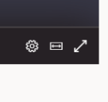
This will take you directly to the video stream. When you get there, click on the double arrow to enlarge the screen.
Don’t forget to Doodle!

Phonics – To learn more about the prefix ‘un’,
Last week we started to look at the prefix un. Read the story about Mr Un. Can you make a list of 5 words featuring un in the story.
Describe Mr Un.
Why do you think Mr Un was unhappy?
How did Mr and Mrs Happy cheer him up?

Optional activities :Music
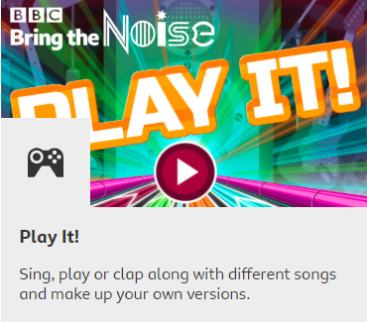
Go to : https://www.bbc.co.uk/games/embed/bring-the-noise?exitGameUrl=https%3A%2F%2Fbbc.co.uk%2Fteach%2Fbring-the-noise%2Feyfs-ks1-music-play-it-bring-the-noise%2Fz4sq92p

You can have great fun creating, listening, moving and playing along….just click on ‘How to play’.
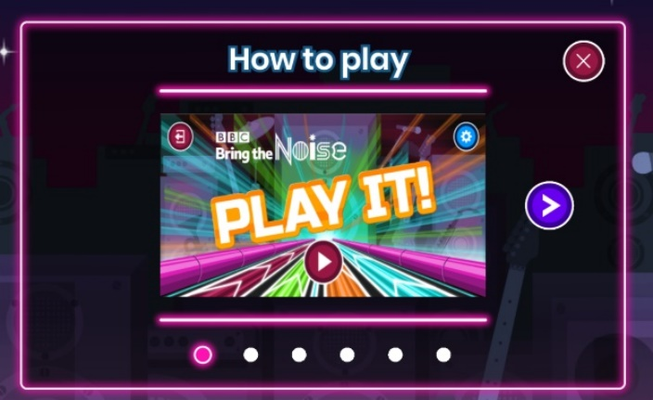
Think about timbre / dynamics / duration in music - linked to opposites

There is some extra information on the web page to help you learn lots about music too. Listen to different sounds and try to match these to adjectives describing sound quality (timbre) dynamics (volume) and duration (length). Can they match the opposites? They are then to explore sounds in the home. Can they collect a sound for each quality?

PE
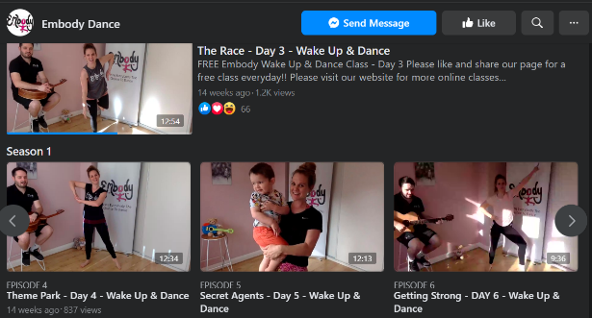
We have been having fun doing the Embody routines in class. You might want to have a go yourself if you have a Facebook page mums and dads. Click on the picture right or follow:
https://www.facebook.com/EmbodyDanceCompany/videos/

