Friday 26th June
Phonics Quiz
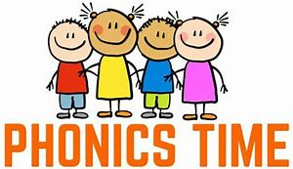

Read the real and alien words on the PowerPoint and then answer the questions below.
- Which word rhymes with greed? …………………

- A large, orange vegetable ……………………

- A word with the suffix ‘ing’ ………..…………………

- Which alien word has the spilt digraph a-e? ……………………………

- Which alien word rhymes with brisk? ……………………………

- The opposite of polite is ………………..

- This alien word ends with an ‘air’ phoneme ……………….

- This alien is green and is made up of 4 phonemes (sounds)……………..

