Bramingham Primary School – RE Knowledge Organiser
Topic: Who is Jewish? | Year 2 | Strand: Judaism
Vocabulary
Festival | A celebration
God | A supreme being
Torah | Jewish holy scripture
Scripture | God’s written words
Sacred | Having a very special purpose
Synagogue | a special place of worship for Jewish people.
Shema | is the most ancient Jewish prayer that can be found in the Torah.
Shabbat | A festival of resting
Jewish | is a follower of the religion ‘Judaism’, Jews believe in one God and their messenger was Moses.
Moses | a religious leader in Judaism.
Yad | is a pointer used to point in a Torah.
Hannukah | The Jewish Festival of Lights.
Greggor | Wooden rattle used in a Jewish festival.
Star of David | The Jewish religious symbol.
kippa | A special hat worn when praying, attending the synagogue or at a religious event or festival.
Mezuzah | The Shema can be found inside a Mezuzah
Challah bread | Special bread eaten at Sabbat
Tallit | Cloth to cover the Challah bread

Jewish artefacts |  | Jewish festival- Shabbat |  | Jewish festival- Hannukah
These are special objects that Jewish people might have in their home may include: mezuzah, candlesticks, challah bread, challah board, challah cover, wine goblet, other kosher food, Seder plate, matzah cover, Star of David on a chain, prayer books, hanukiah, kippa  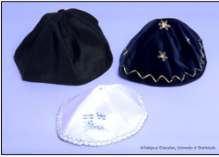  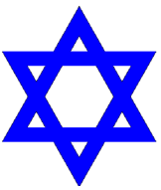 |  | The Sabbath or Shabbat (the Hebrew word for ‘Sabbath’) is the seventh day of the week. Jews celebrate the Sabbath every week. The Sabbath begins at sunset on Friday and lasts until nightfall on Saturday.Jews look forward to Shabbat as it is a time for resting. Time is spent eating and relaxing with family and friends.  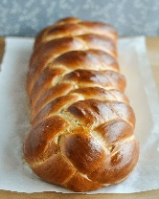  Challah Bread is an important food eaten during Shabbat. |  | 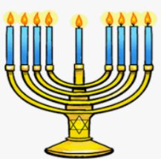  The story of Hanukkah is a festival that reminds Jews of a time over 2500 years ago when a Syrian king, tried to make the Jewish people worship Greek gods. Hanukkah is celebrated by lighting one candle on the Hanukiah (a nine stemmed candelabrum) each day. The Hanukiah symbolises how God looked after the Jewish people at this difficult time.
Pictures of some artefacts |  | The Shema Prayer and Mezuzah |  | The Torah
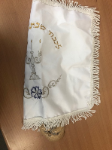  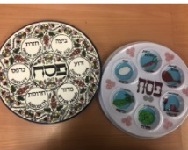  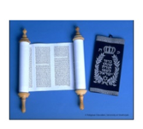 |  | The Shema is an important Jewish prayer which declares the Jewish belief that there is only one God. ‘Hear O Israel, the Lord our God is one Lord'.  It is one of the first prayers learnt by Jewish children.  It is said three times every day by Jewish people.  It is included in nearly every service at the Synagogue. |  | Stories of God is found in the Torah, the stories remind Jews what God is like. The Torah guides Jews how to live life.  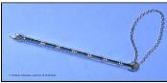  The Torah is handwritten on a scroll, kept in a special place in the synagogue (Ark) and never touched by hands, but with a pointer called a Yad.

