Menu of Home Learning Activities
Wednesday 24th June

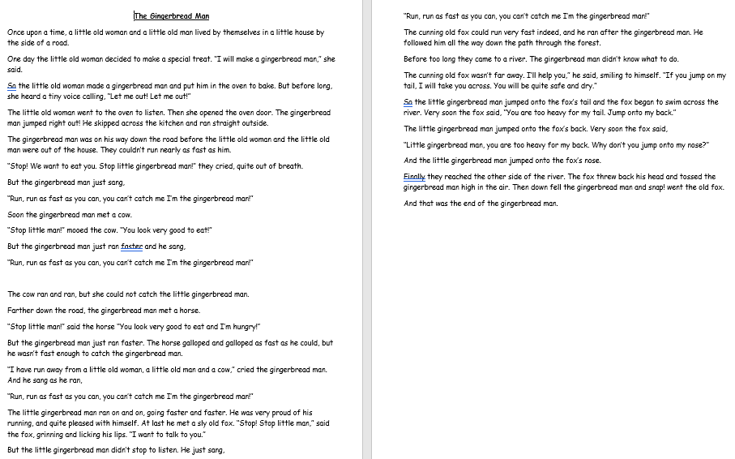
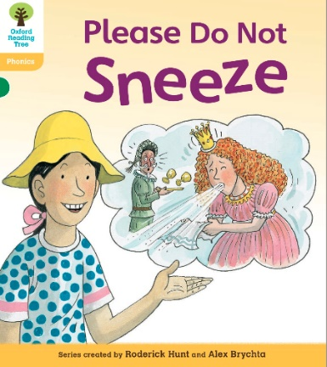
Reading: Learn to read fluently.
Practise reading our class text ‘The Gingerbread Man’ with fluency and expression, especially for the voices!

Writing – Miss Fitzgerald will teach you how to continue writing a new downfall for the gingerbread man. You will use yesterday’s plan to write this section of your story.

Maths – Come and learn about equal grouping
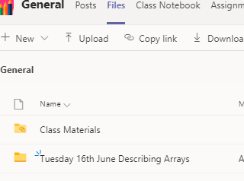
The video and worksheets are also in a folder in Teams Files: Wednesday 24th June in case you have any problem here.
Watch the video we have recorded for you.

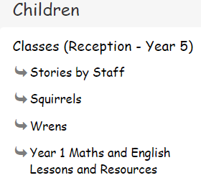
Go to the newly created Bramingham web page called ‘Year 1 Maths and English Lessons and Resources’. See left.

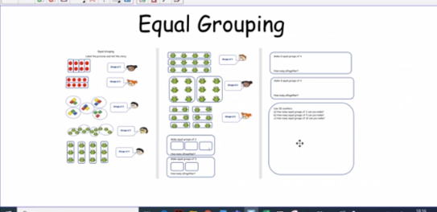
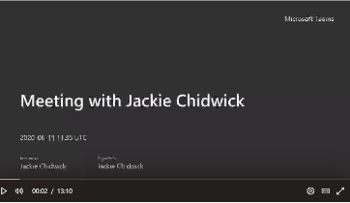
.

Then click on the picture (see left)
It may also appear as this picture:

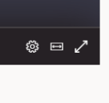
This will take you directly to the video stream. When you get there, click on the double arrow to enlarge the screen.

Don’t forget to Doodle!

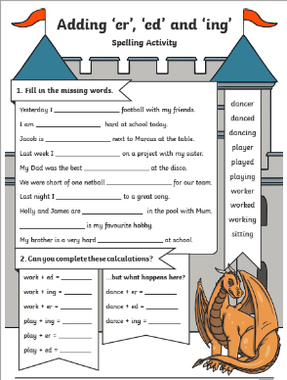
Phonics -
To add ing, ed, and er
Look at our model text. Can you find any words ending in ing, ed or er? These endings are called suffixes.

Watch the video:
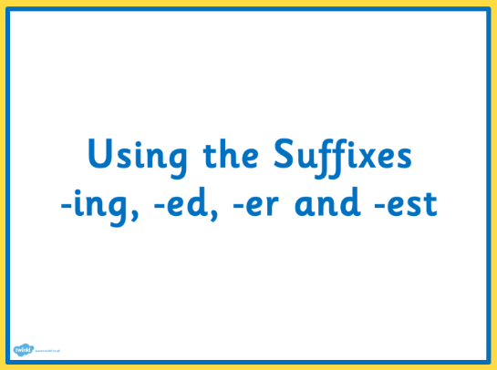
https://www.youtube.com/watch?v=J1UwR97CUYY&list=PLr8_5HYa7f2LWsQ7WBxV0tdKEZ8YC3KOi
and talk about what you have learnt. Then complete the suffixes activity. You may also want to use the slides.

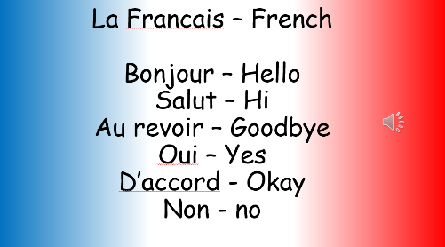
Optional activity: French
Continue to learn key vocabulary (pages 1-4). Revise days of the week on pages 30-31.

PE
Have fun doing 'The Name Workout'. Could you try your sibling's name? How about your surname?
