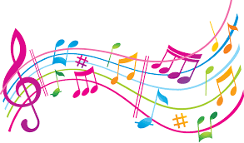
Tuesday 7th July
To describe sounds

In music, there are lots of different ways to describe sounds. We can talk about:
Pitch – whether a sound is high or low/deep.
Duration - whether a sound is long or short.
Dynamics/volume – whether a sound is soft/quiet or loud.
Timbre – what ‘texture’ a sound is, e.g. scratchy or smooth.

Can you match up opposite sound word pairs?

quiet/soft  happy  high  long  smooth  weak |  | short  loud  low/deep  sad  scratchy  powerful

Use your voice, your body or an instrument (or object):
Can you make a loud sound?
Can you make a long sound?
Can you make a high sound?
Can you make a smooth sound?

