Menu of Home Learning Activities
Tuesday 16th June

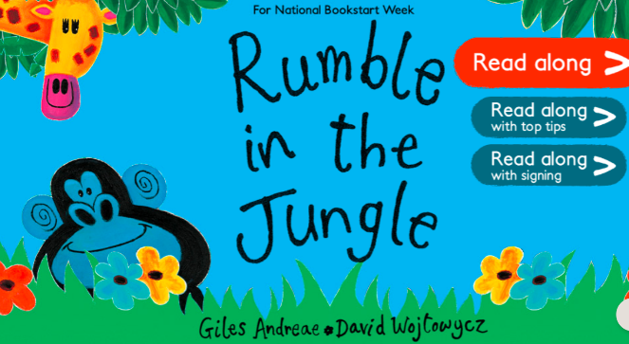
Reading: Learn to read fluently by reading along to Rumble in the Jungle.
Click on the link below….no logging in or registering needed – lots of stories to practise reading along to.
https://www.booktrust.org.uk/books-and-reading/have-some-fun/storybooks-and-games/rumble-in-the-jungle/
Whatever you choose, practise reading until you can read more of it fluently than you could to start with. You can listen to your book as many times as you like. You can send us a video of you reading if you would like to.

Writing – Miss Fitzgerald will teach you to describe a setting. A setting is the place in which a story happens.Please watch the video, pausing to try exercises and answer questions, then have a go at the activities that have been set. Once you have done this, you can join a Year 1 teacher on Teams at 9:30 to discuss your work and show us how you have got on if you would like to. The meeting will be in your calendar.

Phonics – alternate pronunciations for vowel digraph: ie
Can you find the word ‘cried’ in our model text? What sound does the 'ie' make? Do you know that 'ie' can sometimes make a 'long i' sound as in pie, but can also make 'long ee' sound as in piece?
Read the alternative phonemes words. What do you notice? Sort into the words into families, according to the sound that 'ie' makes. Choose two words and write sentences in your book e.g.
There was a huge field opposite the bus stop.
A thief stole money and jewellery in the middle of the night.

Maths – Come and find out what arrays are and why we use them. Then see if you can use all the right mathematical words to describe arrays.

The video and worksheets are also in Teams files in case you have any problem here.

Watch the video we have recorded for you.
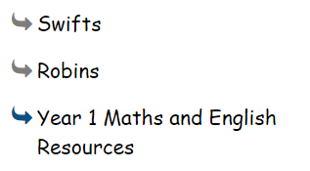
Go to the newly created Bramingham web page called ‘Year 1 Maths and English Resources’. See left.

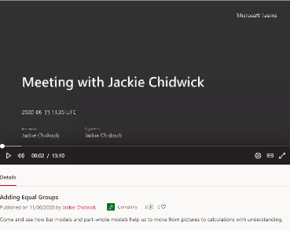
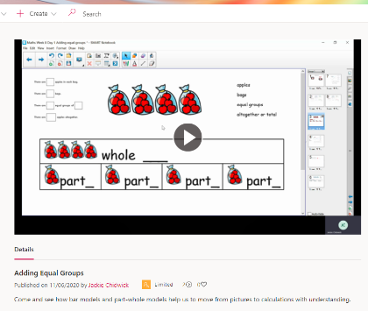
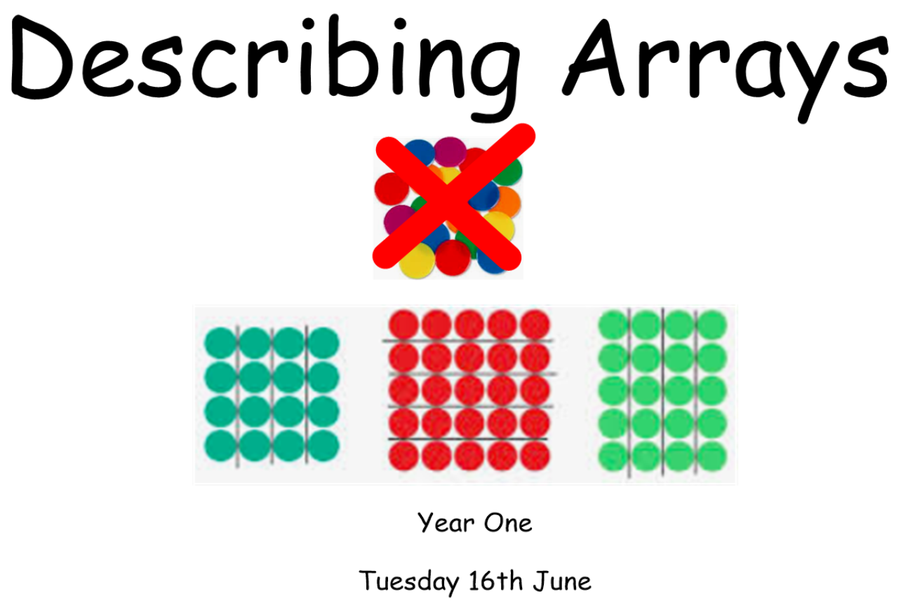.

Then click on the picture (see left)
It may also appear as this picture:

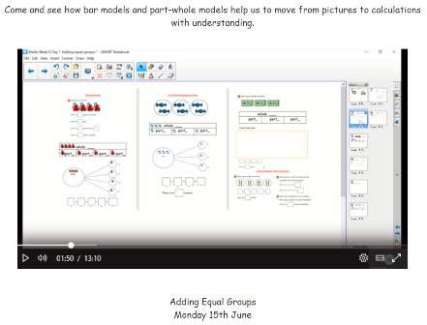
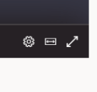
This will take you directly to the video stream. When you get there, click on the double arrow to enlarge the screen.

Don’t forget to Doodle!

Optional activity
History:

To understand how we learn about the past

Last week, we talked about historical sources. These are objects and other evidence that historians use to find out about the past. Can you remember any historical sources? Today, we are planning a time capsule. Open my sheet to find out more.

PE
Have fun doing 'The Name Workout'. Could you try your sibling's name? How about your surname?
