Bramingham Primary School - Science Knowledge Organiser
Topic: Using Everyday Materials | Year 2
What should I already know?
Objects are things that you can touch or see. •
Objects are made from materials. •
Some materials that objects are made from (e.g. glass, wood, plastic) • Some words to describe materials (e.g. shiny, soft, absorbent, rough)
Materials which are natural and which are man-made
Vocabulary
absorbent | material that soaks up liquid a lot
bendy | moves easily into another shape
brick | baked clay used to build houses
dull | not bright
elastic | a rubber material that stretches when you pull it and returns to its original size and shape when you let it go
fabrics | cloth or material such as cotton
foil | sheets of metal as thin as paper
glass | hard transparent material
man-made | things made by people
metal | hard material such as iron, steel, gold
natural | things not made by people
opaque | you cannot see through it
plastic | light manmade material
properties | features of a material
purpose | the reason for something
recyclable | waste or materials which can be used again
rigid | firm or does not bend easily
squash | pressed or crushed with such force that something loses its shape
suitable | something that is suitable for a particular purpose or occasion is right or acceptable for it
transparent | see through
twist | turn something to make a spiral shape
unsuitable | does not have the right properties for the purpose
waterproof | does not let water pass through it
wood | material from trees

What will I learn about materials? |  | What will I learn about how suitable materials are for a particular use?
Materials are used for different purposes based on their properties. •  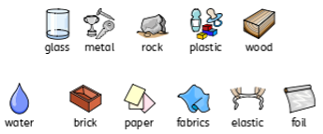  For example, wood is used to make furniture and floors. • Metal can be used to make coins, cans, cars and cutlery. Glass can used to make windows. |  | Glass can used to make windows because it is transparent. •  Rulers can be made from wood, plastic or rubber because these materials are smooth and can be cut straight. • Spoons are made from metal, because it is waterproof and can be cleaned easily. • They can also be made from plastic for children because plastic is light and it cannot hurt children’s growing teeth.  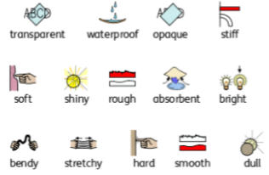

What will I learn about how to change the shape and size of materials?
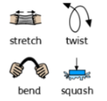
The shape and size of some materials can be changed when they are stretched, twisted, bent, squashed, cut, drilled.

