Menu of Home Learning Activities
Thursday 25th June

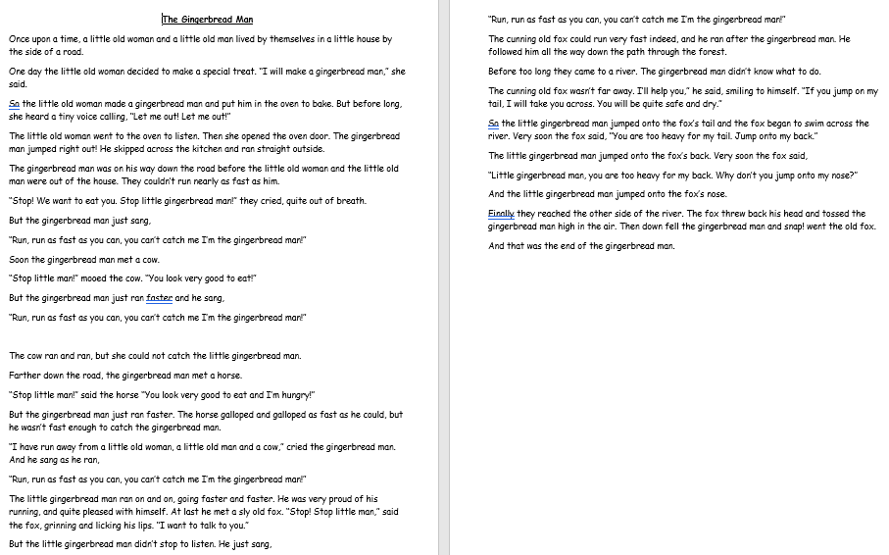
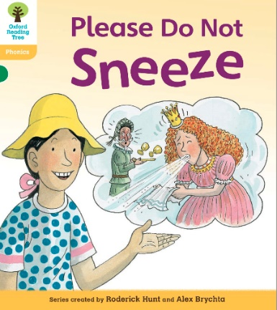
Reading: Learn to read fluently.
Practise reading our class text ‘The Gingerbread Man’ with fluency and expression, especially for the voices!

Writing – Miss Fitzgerald will teach you how to begin your plan for your own story based on ‘The Gingerbread Man’.

Maths – Come and learn about counting to 100
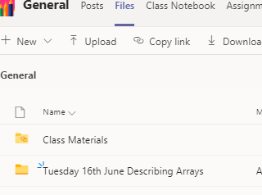
The video and worksheets are also in a folder in Teams Files: Thursday 25th June in case you have any problem here.
Watch the video we have recorded for you.

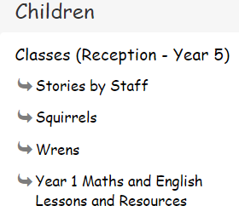
Go to the newly created Bramingham web page called ‘Year 1 Maths and English Lessons and Resources’. See left.

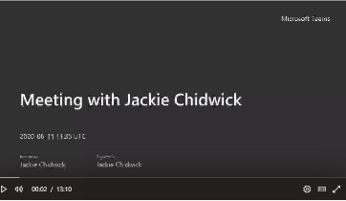
Then click on the picture (see left)
It may also appear as this picture:

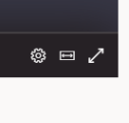
This will take you directly to the video stream. When you get there, click on the double arrow to enlarge the screen.

Don’t forget to Doodle!

Phonics – These are your spelling words. What do you notice about them?

That’s right! They all contain suffixes (word endings). The red words are tricky words for you to learn. Choose a set of words to learn and practise them. Can you write a sentence?

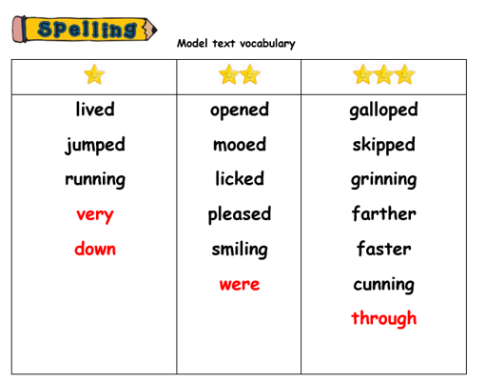
Optional activity: Geography

This week we are learning about the climate and animals living in a hot place. Take a look at the PowerPoint and have a go at answering the questions.

