Menu of Home Learning Activities
Friday 3rd July
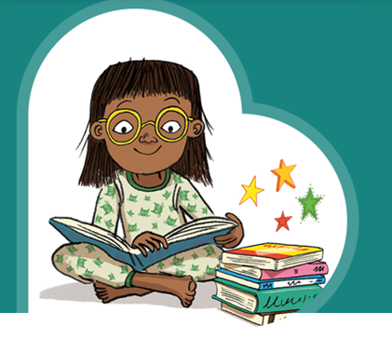
Reading: Learn to read fluently.
Go to https://www.booktrust.org.uk and choose a book to read.

Writing – Miss Fitzgerald will teach you how to write a blurb and design a front and back cover for your book.

Maths – Come and learn about finding 1 more and 1 less
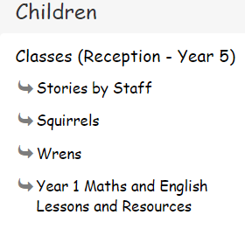
Go to the newly created Bramingham web page called ‘Year 1 Maths and English Lessons and Resources’. See left.
Don’t forget to Doodle!

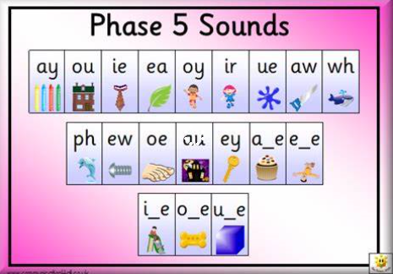
Phonics – Do you know your Phase 5 sounds (phonemes)?

Look at the Phonics Phase 5 PowerPoint and complete the quiz.

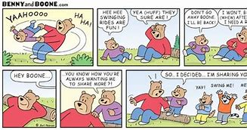
Optional activity:
A comic strip tells a short story using pictures and some words.
Can you make a comic strip for your friends?

