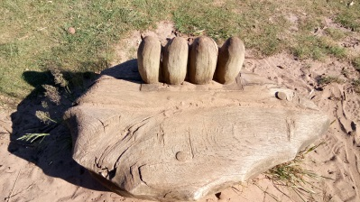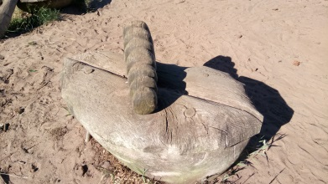 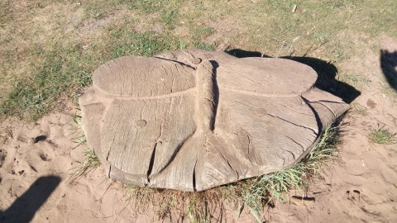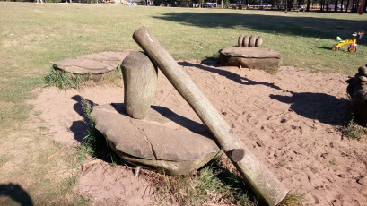

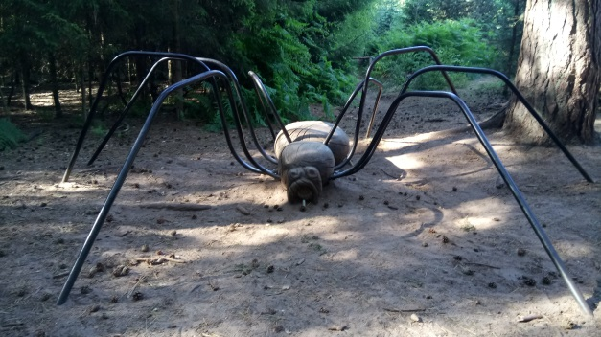 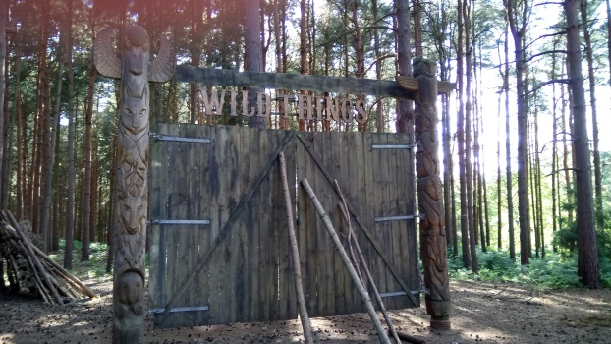 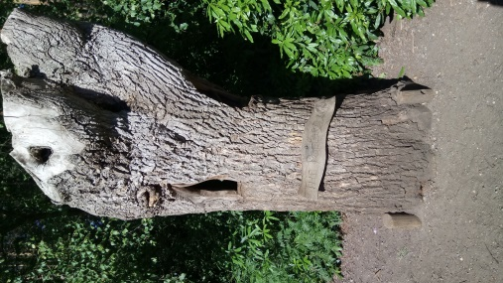

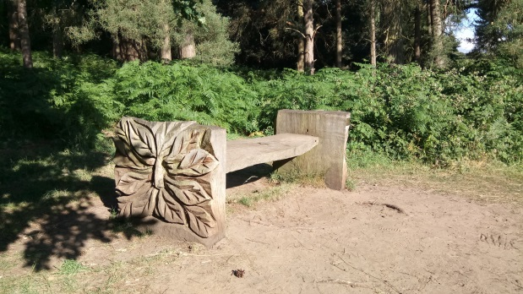 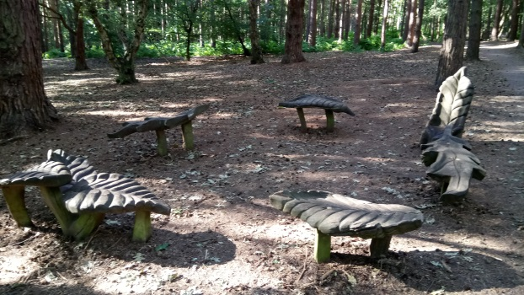 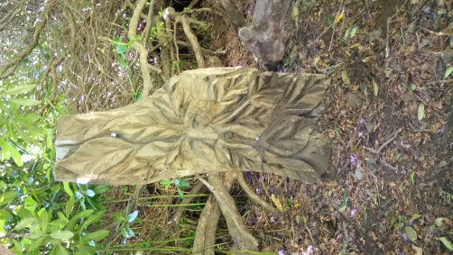

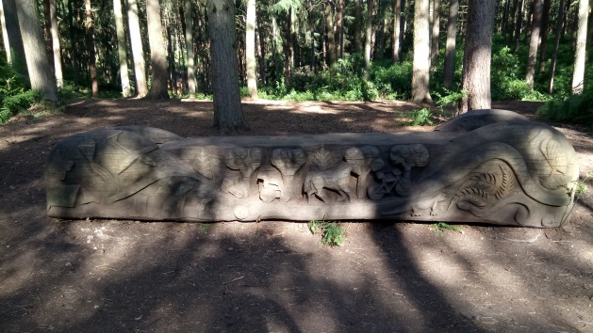 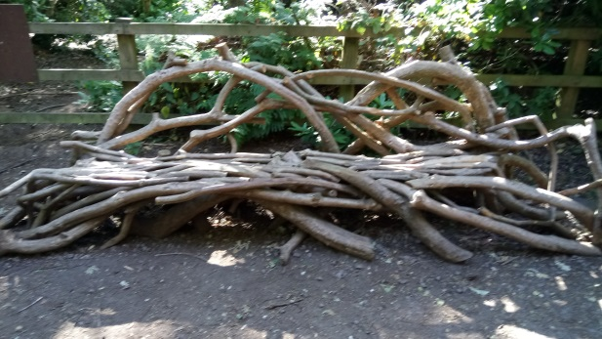

Take a seat…

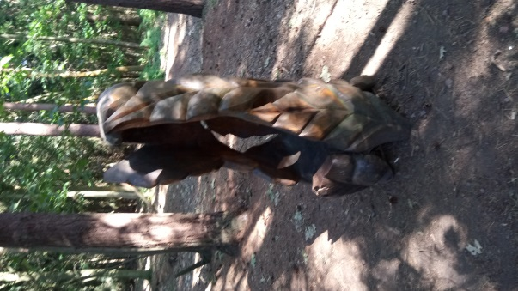 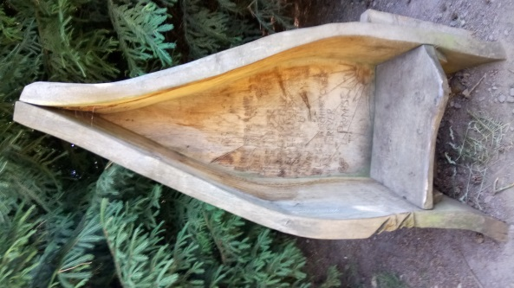 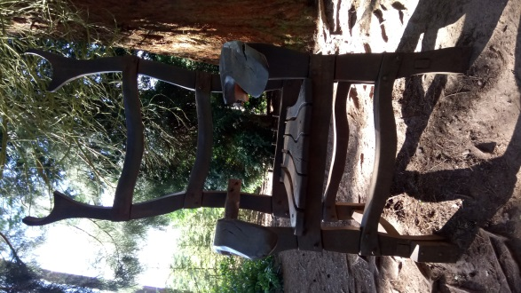 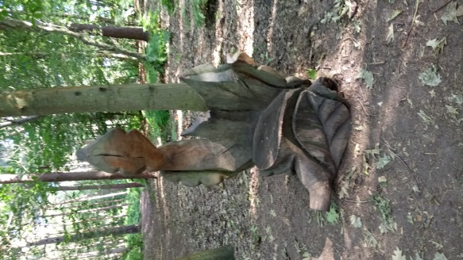

Hidden messages…

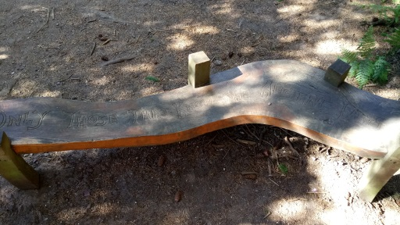 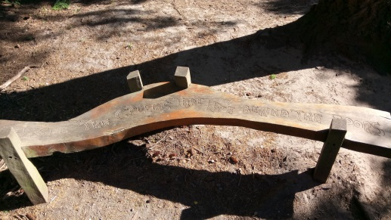

_______________________________________________________________________________________________

_______________________________________________________________________________________________

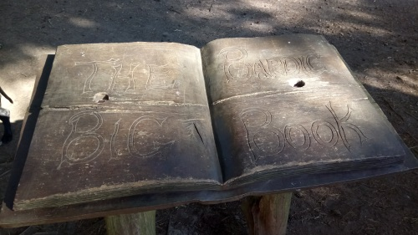_______________________________________________________________

_______________________________________________________________

_______________________________________________________________

__________________________________________________ ____________

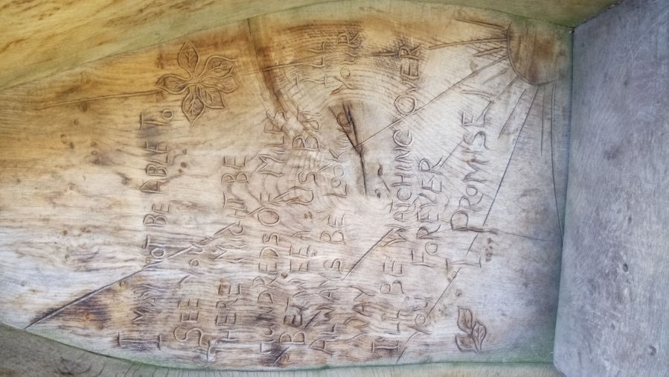__________________________________________________ ____________

__________________________________________________ ____________

__________________________________________________ ____________

__________________________________________________ ____________

______________________________________________________________

__________________________________________________ ____________

__________________________________________________ ____________

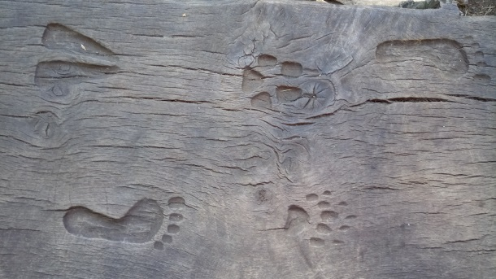Who’s been crossing this bridge?

____________________________________________________________________________________________________________________________________________