Thursday 2nd July
To know about a cold place – The Antarctic

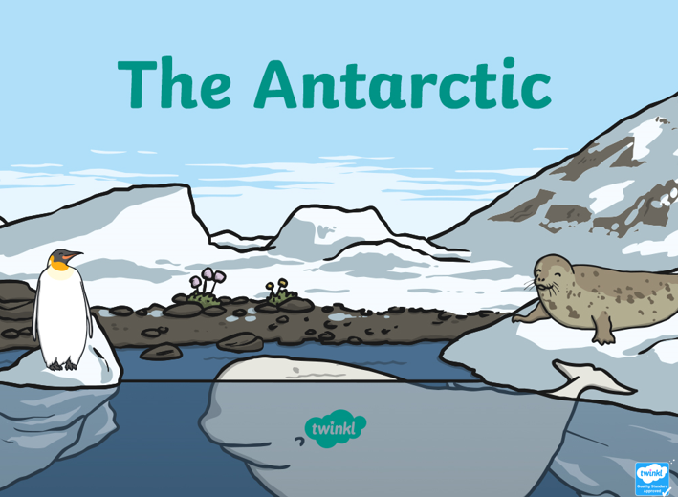

We are learning about the weather, climate and animals found in a cold place. Today we will be visiting the Antarctic! Read the information on the PowerPoint and have a go at the questions below.
- Where is the Antarctic found?
………………………………………………………………………………………………………………………………………………………………………….
- Where was the coldest temperature ever recorded and what was it?
……………………………………………………………………………………………………………………………………………………………………
- Name 3 animals found here.
…………………………………………………………………………………………………………………………………………………………………………
- Which plant life might be found in the Antarctic?
…………………………………………………………………………………………………………………………………………………………………………
- Who works in the Antarctic to find out about new things?
………………………………………………………………………………………………………………………………………………………………………….
- What is an iceberg?
………………………………………………………………………………………………………………………………………………………………………..
- Why do you think nobody lives in the Antarctic?
………………………………………………………………………………………………………………………………………………………………………….
- Would you like to visit the Antarctic? Yes/ No
Explain why
……………………………………………………………………………………………………………………………………………………………..

