Menu of Home Learning Activities
Monday 6th July

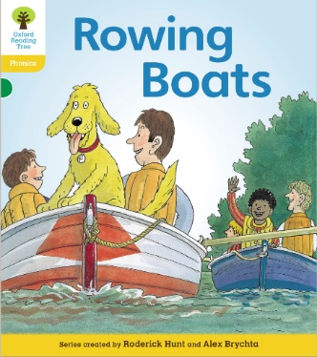
Reading: Learn to read fluently by reading along to Rowing Boats.
Click on the link below
https://www.oxfordowl.co.uk/api/digital_books/1369.html
You will need this book for your phonics today.
Answer these questions by finding the information in the text – remember, comprehension is not a memory test:
See page 3: Where did they put the picnic things?
See page 5:How did Craig row the boat?
See page 8: Where did dad get the plums?
See page 11: What were the boys trying to do?
See page 19: How did Floppy help?

Writing – Miss Fitzgerald will introduce you to how she has written her own reflection on the year and help ou learn to read it. It will help you to begin thinking about what you might want to include on your reflection about your year in Robins class.

Maths – Come and learn about finding a half
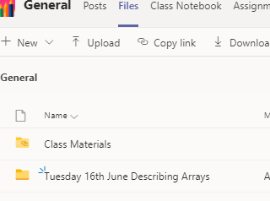
The video and worksheets are also in a folder in Teams Files: Monday 6th July in case you have any problem here.
Watch the video we have recorded for you.

Go to the newly created Bramingham web page called ‘Year 1 Maths and English Lessons and Resources’.
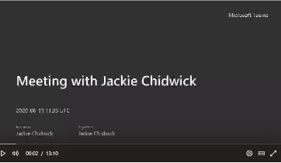
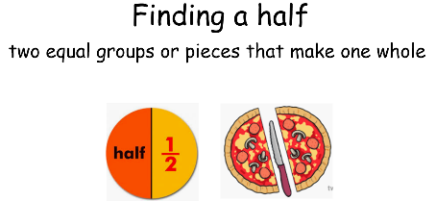
.

Then click on the picture (see left)
It may also appear as this picture:

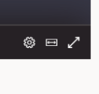
This will take you directly to the video stream. When you get there, click on the double arrow to enlarge the screen.
Don’t forget to Doodle!

Phonics - To To revise alternate graphemes for ow (Ow ow blow the snow)
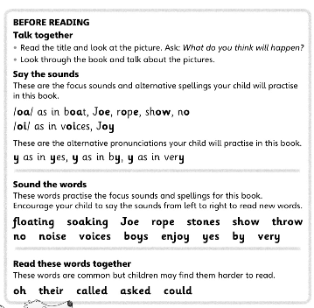
Read ‘Rowing Boats’ e book on oxfordowl.co.uk
Make sure you can say the sounds, sound the words and read the common words before you begin.

What do you notice? There are different graphemes for the ow phoneme.
Make a list of different words using ow, oa, o, oe and o-e graphemes

Answer the comprehension questions at the beginning of this menu.

Optional activities

Computing:Coding

Access Discovery Education Coding at:
https://www.discoveryeducation.co.uk/what-we-offer/discovery-education-coding
Log in: student35491
Password: bramcode
You will begin to work on unit 1b (Simple Inputs). Do Lesson 5

PE
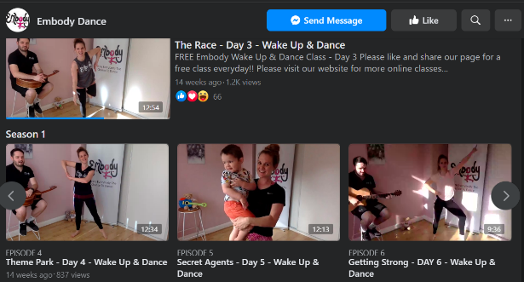
We have been having fun doing the Embody routines in class. You might want to have a go yourself if you have a Facebook page mums and dads. Click on the picture right or follow:
https://www.facebook.com/EmbodyDanceCompany/videos/

