Menu of Home Learning Activities
Friday 26th June

Reading: Learn to read fluently.
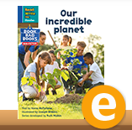
Go to https://www.oxfordowl.co.uk/ and find the book ‘Our incredible planet’.
- Talk about what we could do to protect our planet.
- This week we have been learning about suffixes. Can you find any words which include suffixes?

Writing – Miss Fitzgerald will teach you how to continue to plan for your own story based on ‘The Gingerbread Man’.

Maths – Come and learn more about counting to 100
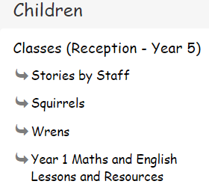
Go to the newly created Bramingham web page called ‘Year 1 Maths and English Lessons and Resources’. See left.
Don’t forget to Doodle!

Phonics – Look at the Phonics PowerPoint and read the real and alien words. Can you complete the phonics quiz?

Optional activity: Let’s make and bake!
Fancy a treat for tea or a friend to play with?
See the recipe for gingerbread people to do some baking or you could get busy with some art and crafts.

