To explore opposites

Explore opposites through drawing. Use opposite adjectives in contrasting sentences. The elephant is big but/whereas the mouse is small.
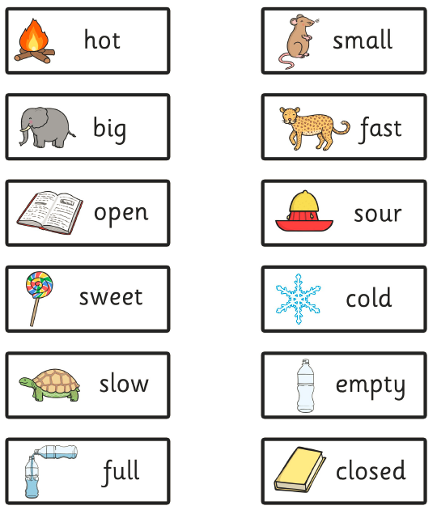

Picture 1 | Picture 2 | Sentences with but  whereas

