Menu of Home Learning Activities
Wednesday 17th June

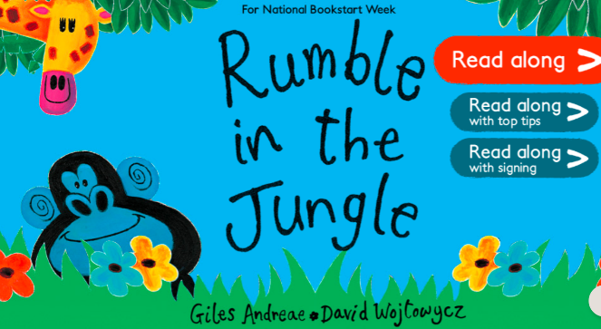
Reading: Learn to read fluently by reading along to Rumble in the Jungle.
Click on the link below….no logging in or registering needed – lots of stories to practise reading along to.
https://www.booktrust.org.uk/books-and-reading/have-some-fun/storybooks-and-games/rumble-in-the-jungle/
Whatever you choose, practise reading until you can read more of it fluently than you could to start with. You can listen to your book as many times as you like. You can send us a video of you reading if you would like to.

Writing – Miss Fitzgerald will teach you how to innovate on a story. This means to change it. You will also be thinking about alliteration. This means the repetition of initial consonant sounds, e.g. Mary makes marvellous marmalade muffins on Mondays!

Maths – Come and find out more about arrays. You can be the teacher today!
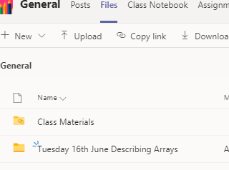
The video and worksheets are also in a folder in Teams Files: Wednesday 17th June More About Arrays in case you have any problem here.
Watch the video we have recorded for you.

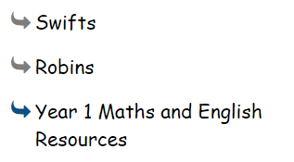
Go to the newly created Bramingham web page called ‘Year 1 Maths and English Resources’. See left.

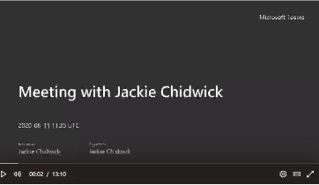
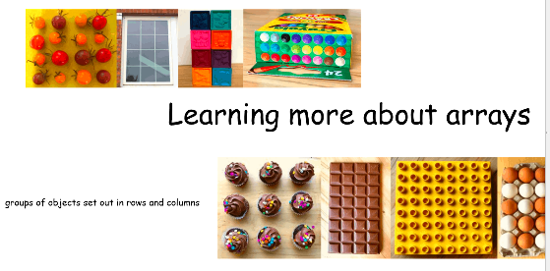
.

Then click on the picture (see left)
It may also appear as this picture:

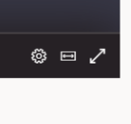
This will take you directly to the video stream. When you get there, click on the double arrow to enlarge the screen.

Don’t forget to Doodle!

Phonics – To learn ‘y’ (as in ee)
Watch Mrs Bharaj’s video.
Can you find the word ‘tiny’ in our model text. What do you notice?
Y can make y sound as in yak, a long i sound as in fry, cry, sly and the ee sound as in tiny, baby, family.
(additional notes: y also makes ‘i’ sound as in gym, crystal, system!)
Complete the alternative spellings for ‘ee’ sheet. Can you say a sentence with an ee, ey, ea, y and e-e word? For example We had a delicious ice cream under the tall, leafy tree. When my mummy was poorly she had a cup of tea.

Optional activity
Music:
To listen and respond to a piece of music

Music is amazing, isn’t it? It can make us happy, sad, or make us want to dance! What is your favourite song? Why is that? What is your mum or dad’s favourite song? Do you like it?
Choose a piece of music – one you really love. Listen to it. Have a dance and march to the beat. Can you learn the lyrics (words)? What is the song about? What pictures does it paint in your head? Draw a picture inspired by your piece of music.

PE
Have fun doing 'The Name Workout'. Could you try your sibling's name? How about your surname?
