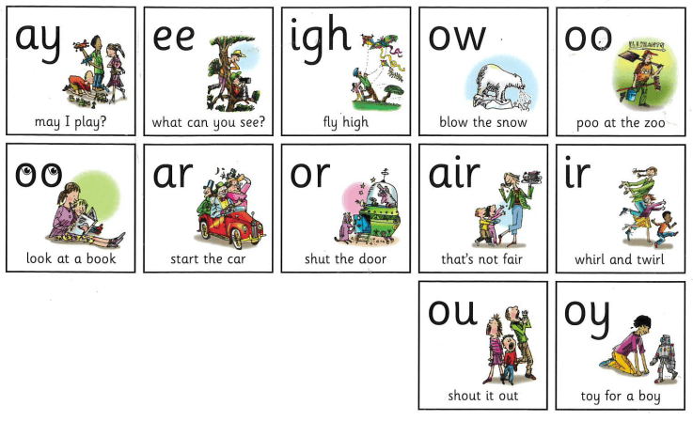

**oor**

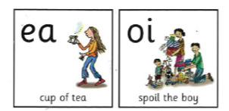

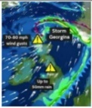

storms in the north

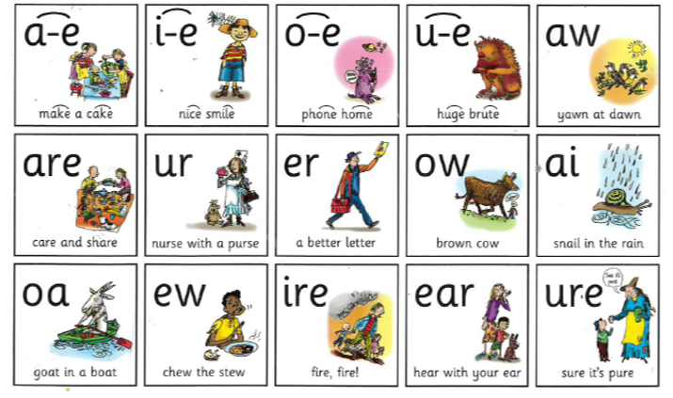

|  |  |  |  |  |
| --- | --- | --- | --- | --- |
| **ch** | **sh** | **th** | **qu** | **ng**    thing on a string |
| **nk**    I think I stink | **ck**    tick tock it’s 3 o’clock | **kn**  the knitting knight | **wh**    Where is Dr. Who? | **ph**    photo of a dolphin |
| **au**    launch the astronaut | **ea**    sweaty head | **ie**    flies on my pie | **oe**  Joe’s toe | **ue**    blue glue |
| **wr**  wriggly writing | **e-e**    Pete the athlete | **ey**    monkey on a donkey | **e**  he,she,me,we,be | **ie**  thief’s shield |
| **tion**  make a celebration | **tch**    witch with an itch | **ore**  explore the shore | **y**  fly in the sky | **tious cious**    scrumptious delicious |