Finding Resources and Fining Children’s Learning on Teams
I hope this help sheet is useful. Please bear with me while I learn how best to support you on Teams!
I am not sure how the page appears for parents but the tab you are looking for is Files:
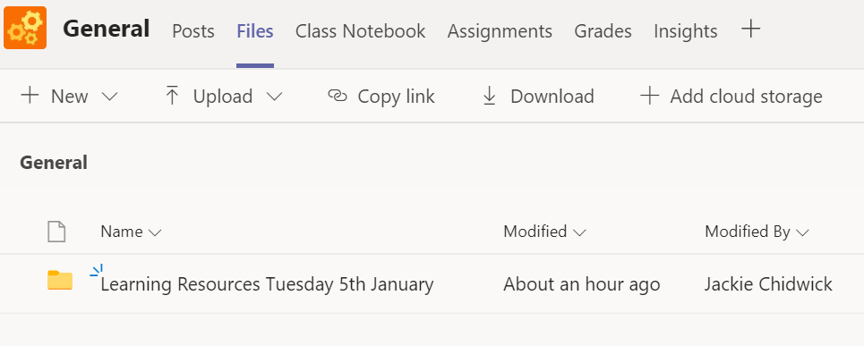
Select the folder you require and you should find all the files inside:
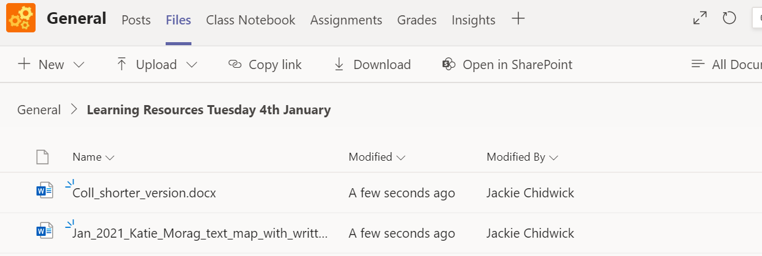
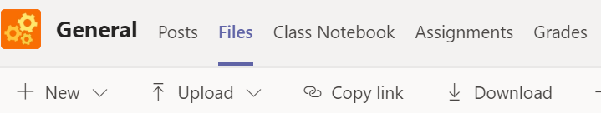
Uploading children’s home learning this week
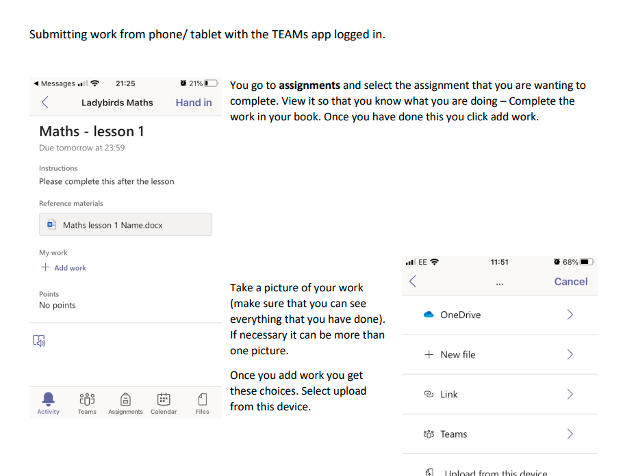
Click on assignments tab:

