Wednesday 17th June
To listen and respond to a piece of music

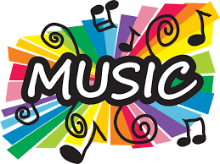

Music is amazing, isn’t it? It can make us happy, sad, or make us want to dance! What is your favourite song? Why is that? What is your mum or dad’s favourite song? Do you like it?
Choose a piece of music – one you really love. Listen to it. Have a dance and march to the beat. Can you learn the lyrics (words)? What is the song about? What pictures does it paint in your head? Draw a picture inspired by your piece of music.

