Menu of Home Learning Activities
Wednesday 1st July
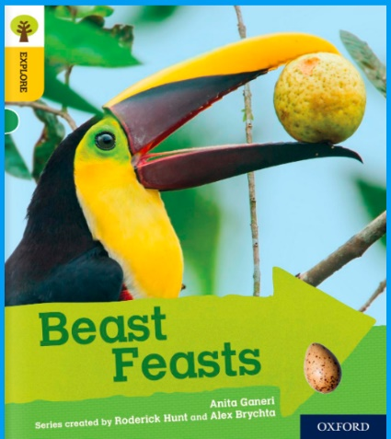
Reading: Finding information in Beast Feasts
Click on the link below to practise reading along to.
https://www.oxfordowl.co.uk/api/digital_books/1352.html
- What is a contents page ?
- What page will help you to find out about arnivores?
- Read the answer to this question on page 5: What is a herbivore?
- Read the answer to this question on page 6: What is carnivore?
- Read the answer to this question on page 7: What is an omnivore?
- Read the answer to this question on page 10: What does an elephant do with its trunk?

Writing – Miss Fitzgerald will teach you how to write the next part of the final version of your story. We have had some exciting stories by so many Robins.

Maths – Come and learn about ordering numbers up to 100
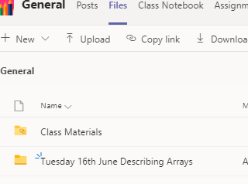
The video and worksheets are also in a folder in Teams Files: Monday 22nd June in case you have any problem here.
Watch the video we have recorded for you.

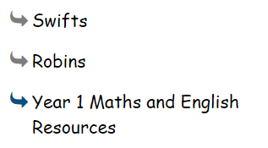
Go to the newly created Bramingham web page called ‘Year 1 Maths and English Resources’. See left.

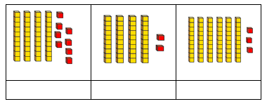
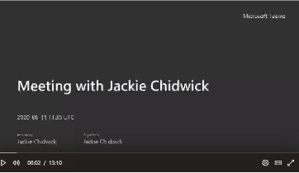
.

Then click on the picture (see left)
It may also appear as this picture:
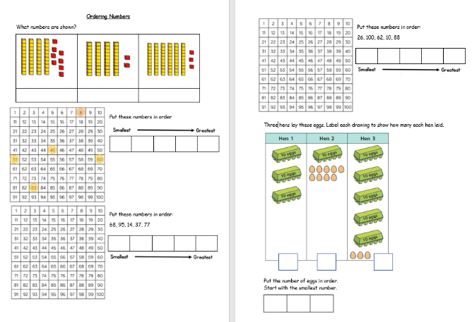

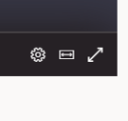
This will take you directly to the video stream. When you get there, click on the double arrow to enlarge the screen.

Don’t forget to Doodle!

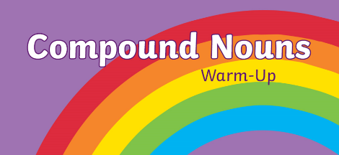
Phonics - To learn compound words
Compound words are words made up of two or more smaller words that are put together to make a new word with its own meaning. Have a look at the Powerpoint and complete the sheet.
Challenge!
Look at our model text. Can you find any compound words?( I found 3!)

Optional activity: To explore opposites
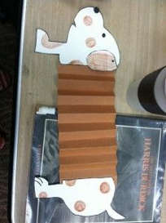
To explore opposites - make a dog that can be long or short. A template is attached on the web page for you to use. You could also make a person who can be tall or short.

French
To practise
Comment tu t’appelles? Je m’appelle...
Continue to learn the days of the week:
Lundi, mardi, mercredi, jeudi, vendredi, samedi, dimanche/
C’est quel jour?
Aujourd’hui, c’est...

PE
Have fun doing 'The Name Workout'. Could you try your sibling's name? How about your surname?
