Bramingham Primary School - Geography Knowledge Organiser
Topic: Direction, Continents and Oceans | Year 2 | Strand: Locational Knowledge/Human and Physical geography
I know |  | Where do I live?
I live in England.  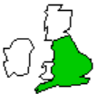  •  I live in Luton. • |  | England is in  Europe  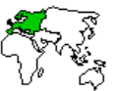
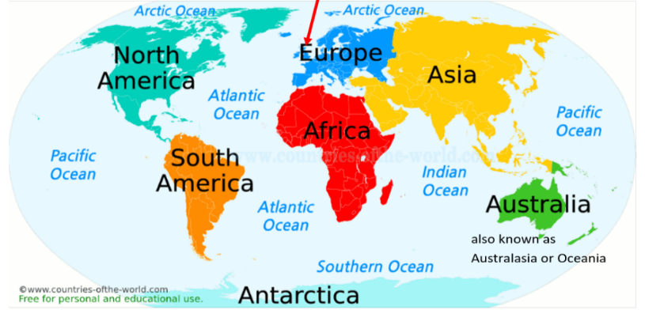
Direction? |  | My continent |  | My ocean
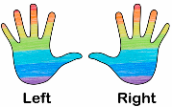  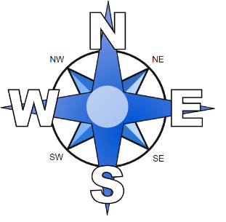 |  | Europe • |  | Atlantic Ocean •

Vocabulary
live

Luton town
England
Europe
ocean

