Gingerbread People

Ingredients
- 350g/12oz plain flour, plus extra for rolling out
- 1 tsp bicarbonate of soda
- 2 tsp ground ginger
- 1 tsp ground cinnamon
- 125g/4½oz butter
- 175g/6oz light soft brown sugar
- 1 free-range egg
- 4 tbsp golden syrup

To decorate
- writing icing (optional)
- cake decorations (optional)

Method
- Sift together the flour, bicarbonate of soda, ginger and cinnamon and pour into the bowl of a food processor. Add the butter and blend until the mix looks like breadcrumbs. Stir in the sugar.
- Lightly beat the egg and golden syrup together, add to the food processor and pulse until the mixture clumps together. Tip the dough out, knead briefly until smooth, wrap in cling film and leave to chill in the fridge for 15 minutes.
- Preheat the oven to 180C/160C Fan/Gas 4. Line two baking trays with greaseproof paper.
- Roll the dough out to a 0.5cm/¼in thickness on a lightly floured surface. Using cutters, cut out the gingerbread men shapes and place on the baking tray, leaving a gap between them.
- Bake for 12–15 minutes, or until lightly golden-brown. Leave on the tray for 10 minutes and then move to a wire rack to finish cooling. When cooled decorate with the writing icing and cake decorations, if using.
Gingerbread Art and Craft
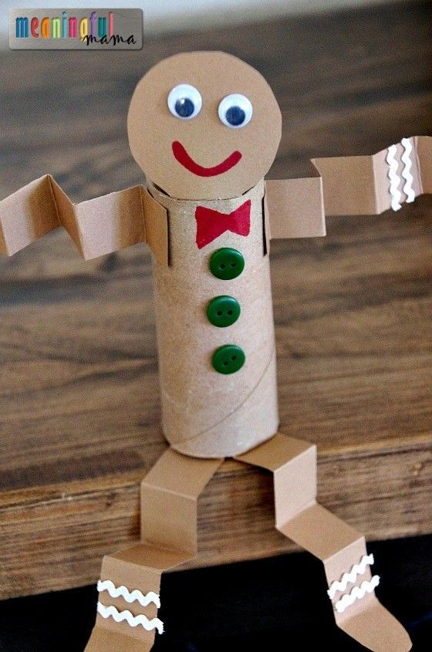
Can you make a gingerbread person using materials in your home?
You could use a toilet roll, cardboard pieces, old buttons and other bits and pieces!
Can you tell your story using your creation?

