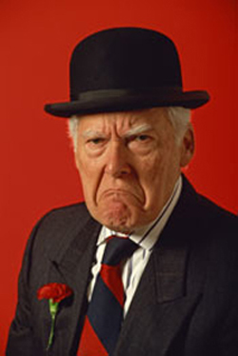
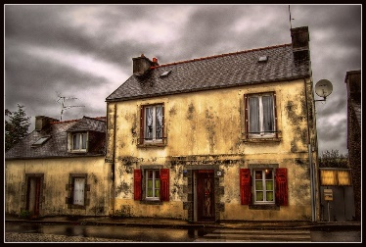
Mr Un

Once upon a time there was a grumpy man. His name was Mr Un. He lived in an untidy house on an unclean street.
Mr Un was a very unkind man. His neighbours, Mr and Mrs Happy, came around one day to ask him a question.
“Will you help us paint our house?” they asked.
Mr Un was unkind. “No, I will not help you. Go away!” He shut the door on them.
Mr and Mrs Happy were very upset. They would help Mr Un if he needed it! What an unhelpful man.
They went back home, unlocked their door and went in.
“What can we do about Mr Un?” Said Mrs Happy. She unzipped her coat and sat down.
“We need to cheer him up!” Mr Happy called from the other room.
Mr and Mrs Happy planned a surprise. They worked all night making a present for Mr Un. They wanted to give Mr Un a treat that would turn him from an unhappy, unkind and unhelpful man, into a kind and friendly man.
The next morning, they crept over to Mr Un’s house.
They put the present on the doorstep, rang the bell and ran back home.
Mr Un heard the doorbell and unlocked the door. He saw the gift on the doorstep. He picked it up. “This is unusual.” He thought.
Mr Un took the present inside and started to unwrap it. He unpacked the box and looked inside.
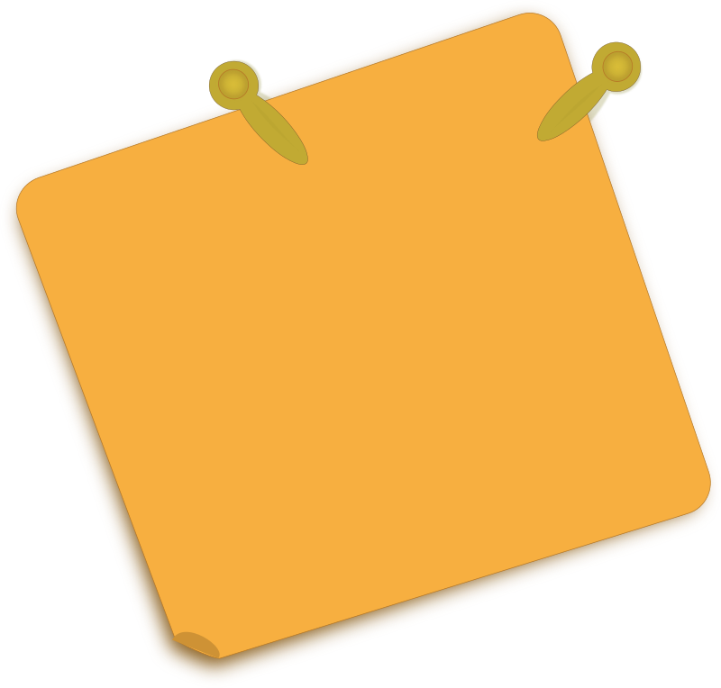
It was a big wooden statue of a dog. Mr Un did not like people, but he did like dogs! He unpicked the paper to find a note. He read the note:
To Mr Un,

Enjoy this present. We hope the dog will cheer you up.
From Mr & Mrs Happy

Mr Un did not feel unhappy anymore. He did not want to be unkind.
Mr Un went to his shed. He found a paintbrush and some cheerful yellow paint.
He ran next door to find his neighbours who were out trying to paint their house.
“Let me help you!” shouted Mr Un.
Everyone painted the house together and they laughed and told stories all day long.
From that day on, Mr Un was never unhappy again.
The End.

