Menu of Home Learning Activities
Tuesday 30th June
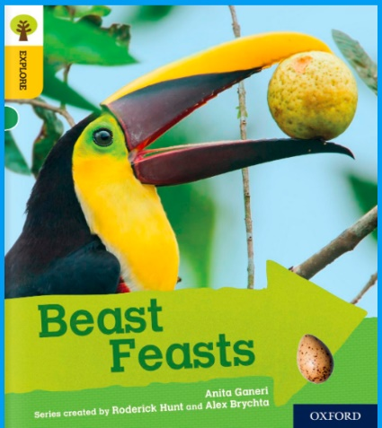
Reading: Learn to read fluently by reading along to Beast Feasts
Click on the link below to practise reading along to.
https://www.oxfordowl.co.uk/api/digital_books/1352.html

Writing – Miss Fitzgerald will teach you how to write the middle of your final version of your story. We have had some exciting stories by so many Robins.

Maths – Come and learn more about comparing numbers up to 100
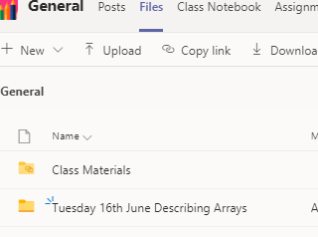
The video and worksheets are also in a folder in Teams Files: Monday 22nd June in case you have any problem here.
Watch the video we have recorded for you.

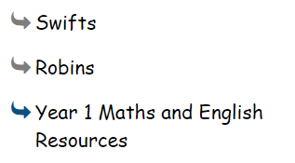
Go to the newly created Bramingham web page called ‘Year 1 Maths and English Resources’. See left.

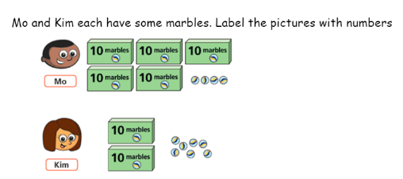
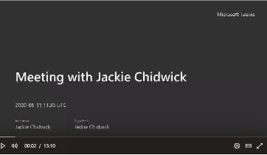
.

Then click on the picture (see left)
It may also appear as this picture:

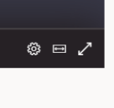
This will take you directly to the video stream. When you get there, click on the double arrow to enlarge the screen.

Don’t forget to Doodle!

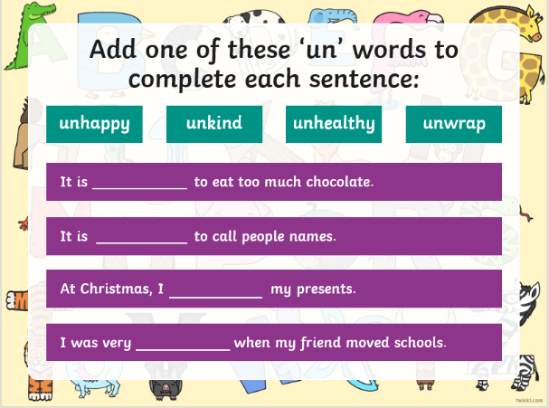
Phonics - To learn about the prefix ‘un’,
Read the information about the prefix ‘un’ and complete the activity.

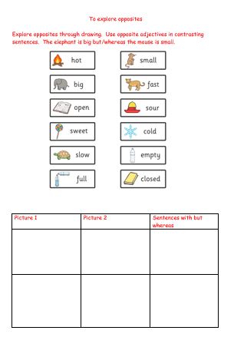
Optional activity: To explore opposites

Explore opposites through drawing. Use opposite adjectives in contrasting sentences. The elephant is big but/whereas the mouse is small.

PE
Have fun doing 'The Name Workout'. Could you try your sibling's name? How about your surname?
