Menu of Home Learning Activities
Friday 19th June

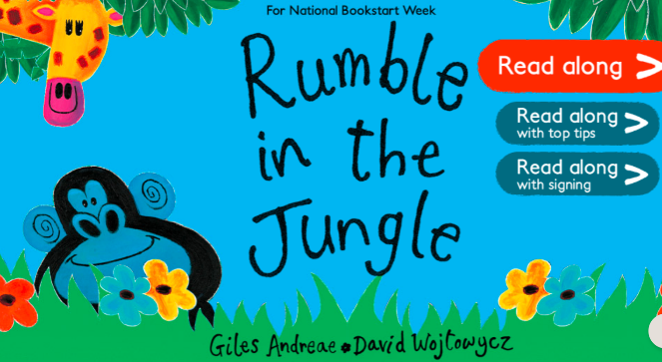
Reading: Learn to read fluently by reading along to Rumble in the Jungle.
Click on the link below….no logging in or registering needed – lots of stories to practise reading along to.
https://www.booktrust.org.uk/books-and-reading/have-some-fun/storybooks-and-games/rumble-in-the-jungle/
Whatever you choose, practise reading until you can read more of it fluently than you could to start with. You can listen to your book as many times as you like. You can send us a video of you reading if you would like to.
Maths – Mrs Bharaj will teach you how to solve problems involving doubles.
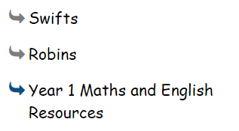
Go to ‘Year 1 Maths and English Resources’. See left.

Don’t forget to Doodle!

Writing – Miss Fitzgerald will teach you how to innovate on a story. Go to the ‘Year 1 Maths and English Resources’ page.

Phonics – To decode real and alien words

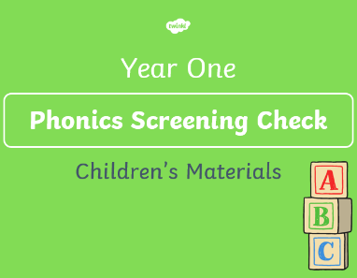
Read the real and alien words and then have a go at the quiz.

Optional activity
PE:
To do some yoga
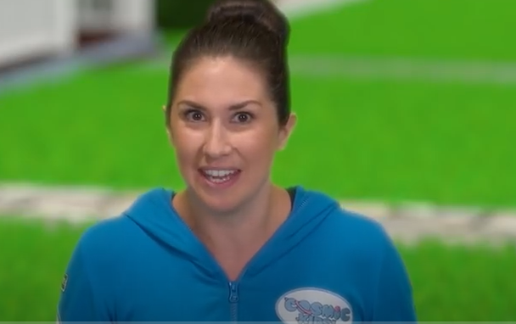

https://www.youtube.com/watch?v=ArOzn2dtDdA

