12th September 2022

Dear Parents,

Milk Money- Autumn Term
If your child would like to have milk from Monday 26th September, the cost for Autumn Term will be £15.12. Unfortunately, the cost of a carton of milk has increased to 28p. In line with the government’s Food Based Standards, please note that the milk purchased for the children will be semi-skimmed milk.
Payments can only be made by logging onto your School Money/ Eduspot account. Please ensure you pay by Monday 19th September at the latest. We are unable to accept any cash payments.
There is no charge for milk for children who are entitled to receive free school meals and are registered with Luton Council. If your child is entitled to free school meals, we will send you a text to ask if you would like your child to have milk. Please ensure you respond to the text promptly so the order can be placed.
Yours sincerely,

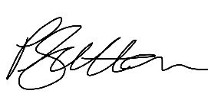
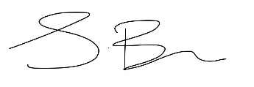

Satinder Bains & Petra Sutton
Joint Acting Headteachers

