Tuesday 16th June
To understand how we learn about the past

How do we know about things that happened long ago? We use historical sources.
Can you remember any?
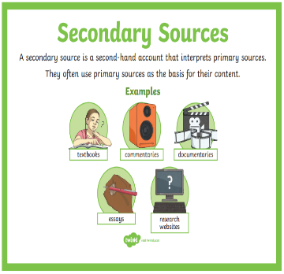
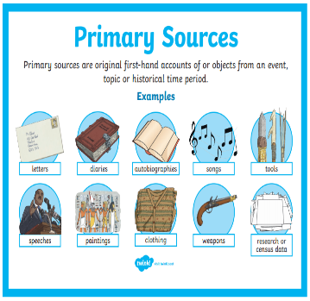

In 100 years’ time, people will want to know what it was like for us living through the Coronavirus Lockdown. What could we put into a special box (time capsule) for them to look at to help them to learn?
Example: We could put a face mask in to help them to understand that some people wore them to stay safe.
You could draw or write any ideas that you have:

