Menu of Home Learning Activities
Monday 22nd June

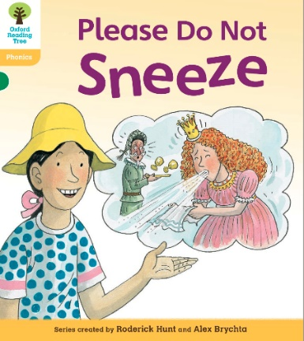
Reading: Learn to read fluently by reading along to Please Do Not Sneeze.
Click on the link below to practise reading along to.
https://www.oxfordowl.co.uk/api/digital_books/1352.html
https://www.oxfordowl.co.uk/for-home/library-page/?query=Please+Do+Not+Sneeze
You will use this in phonics today.

Writing – Miss Fitzgerald will teach you how to plan a new character and downfall for the gingerbread man. Can you create a new character to replace the sly old fox? It’s fun when you begin to make up your own story!

Maths – Come and learn about equal groups by sharing
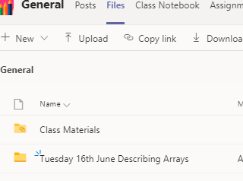
The video and worksheets are also in a folder in Teams Files: Monday 22nd June in case you have any problem here.
Watch the video we have recorded for you.

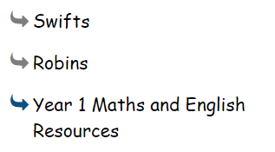
Go to the newly created Bramingham web page called ‘Year 1 Maths and English Resources’. See left.

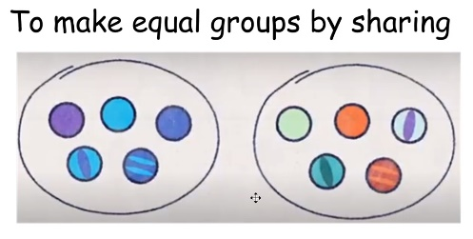
.

Then click on the picture (see left)
It may also appear as this picture:

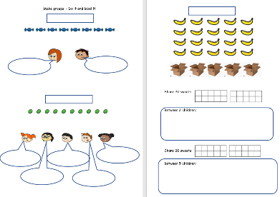

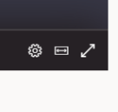
This will take you directly to the video stream. When you get there, click on the double arrow to enlarge the screen.

Don’t forget to Doodle!

Phonics - Revise alternate graphemes for ee (ey, ie, e_e,ea, y)
Read ‘Please do not Sneeze’
https://www.oxfordowl.co.uk/for-home/library-page/?query=Please+Do+Not+Sneeze
Make a list of all the words with the ey, ie, ee, ea, y and e-e grapheme.

Optional activity
Computing:Coding

Continue learning to code by accessing Discovery Education Coding.
Log in: student35491
Password: bramcode
Do lesson 3 of unit 1b (Simple Inputs).

PE
Have fun doing 'The Name Workout'. Could you try your sibling's name? How about your surname?
