Menu of Home Learning Activities
Thursday 2nd July

Reading
To read a book fluently
Log onto https://www.oxfordowl.co.uk/api/interactives/29251.html and read this book. Then talk about the book and answer the questions at the back. Did you notice any compound words? One of our spelling words is in there! Can you spot it?
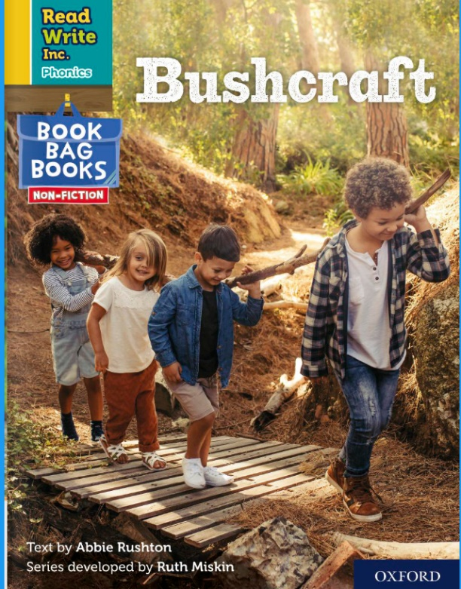
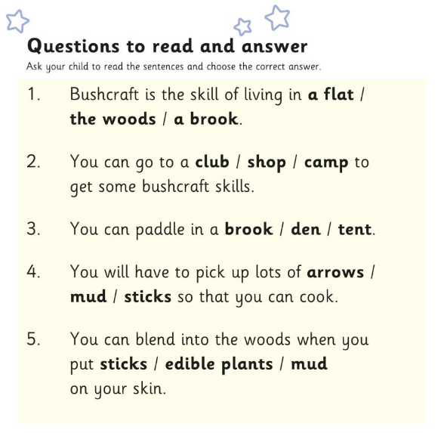
Maths – Come and learn about ordering numbers up to 100.
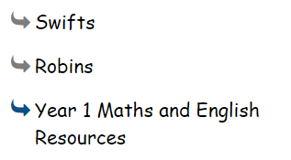
Go to ‘Year 1 Maths and English Resources’. See left.

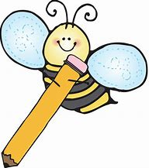

Writing – Miss Fitzgerald will teach you how to write the end of a story.

Don’t forget to Doodle!

Phonics – To learn spelling words
This week we have been learning all about compound words. Choose a set of words to learn and practise them. Can you write a sentence using a conjunction (joining word)?
Across the field I could see bright bluebells and dainty daisies. Did you notice some alliteration in my sentence?
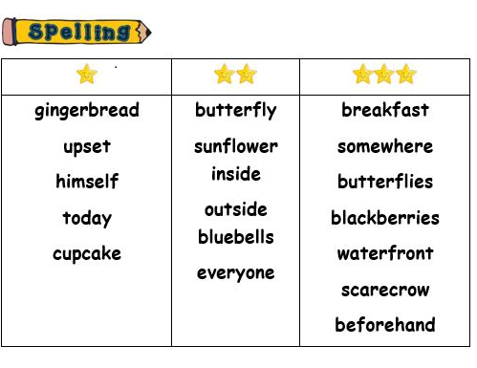

Optional activity
Geography
To know about a cold place

We have been thinking about the world around us. Can you remember the continents? Can you remember the oceans? Can you find The Arctic, The Antarctic and the Equator? Last week we learnt about the climate in South Africa. What is the climate like there?

This week we are going to… The Antarctic! Look at the PowerPoint and then answer the questions.

