Bramingham Primary School - Geography Knowledge Organiser
Topic: Direction, Continents and Oceans | Year 2 | Strand: Locational Knowledge/Human and Physical geography
I know |  | Where do I live?
I live in England. •  I live in Luton. •  England is in the United Kingdom. •  The capital city of England is London. |  | The United Kingdom is in the continent of Europe
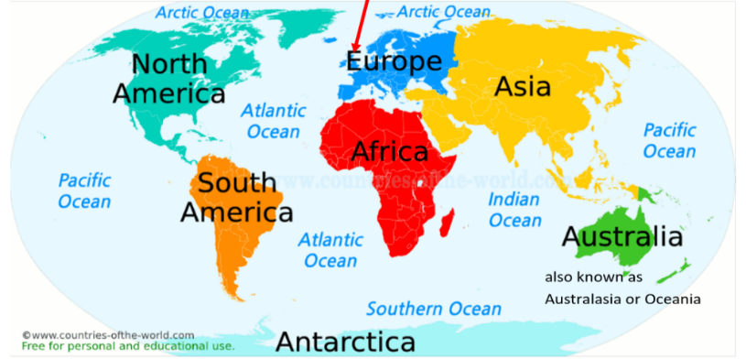
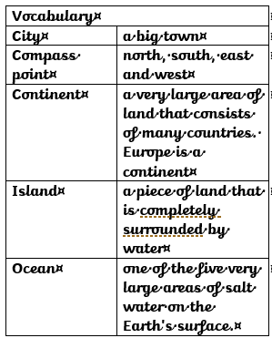
What will I learn about direction? |  | Continents |  | Oceans
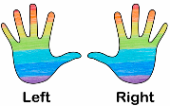  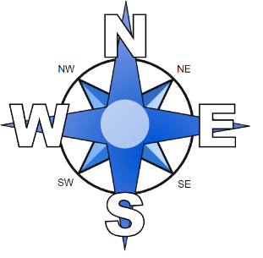 |  | There are seven continents: •  - Europe •  - Asia •  - Africa •  - North America •  - South America •  - Antarctica •  - Australia |  | There are five oceans: •  - Pacific Ocean •  - Atlantic Ocean •  - Indian Ocean •  - Southern Ocean •  - Arctic Ocean

